Appendix A Electrical Connections 83
A.1 Viper PC-104 Single-Board Computer 83
A.1.1 Power 84
A.1.2 USB 84
A.1.3 Ethernet 84
A.1.4 RS-232 COM ports 85
A.2 Z-World LP3500 85
A.2.1 Digital input pin definitions 86
A.2.2 Digital output pin definitions 86
A.2.3 Thermistor A/D and PWM pin definitions 87
A.2.4 RS-232 pin definitions 87
A.2.5 Photometer interface board external connector pin definitions 87
A.2.6 Shutdown board 87
Appendix B Control and Data File Formats 89
B.1 Imager 90
B.1.1 Data files 90
B.1.1.1 Operation log 90
B.1.1.2 IBP background counts 90
B.1.1.3 Full-frame images 90
B.1.1.4 Keogram images 91
B.1.2 Control files 91
B.1.2.1 Full-frame image file 91
B.1.2.2 Command file 92
B.1.2.3 Orbital times file 92
B.1.2.4 Control file 93
B.2 Hertzberg Photometer 94
B.2.1 Data files 94
B.2.1.1 Operation log 94
B.2.1.2 HP and HBP counts 95
B.2.2 Control files 96
B.2.2.1 Orbital times file 96
B.2.2.2 Control file 96
Appendix C Optical Specifications of Instruments 98
C.1 Imager 98
C.2 IBP 98
C.3 HP and HBP 99
Appendix D POWER PROFILE 100
Appendix E Design Documents CD 102
REFERences 103

Electrical Connections

Figure A.1 shows the electrical connections made in the instrument. Each connection is explained in detail in the sections that follow.
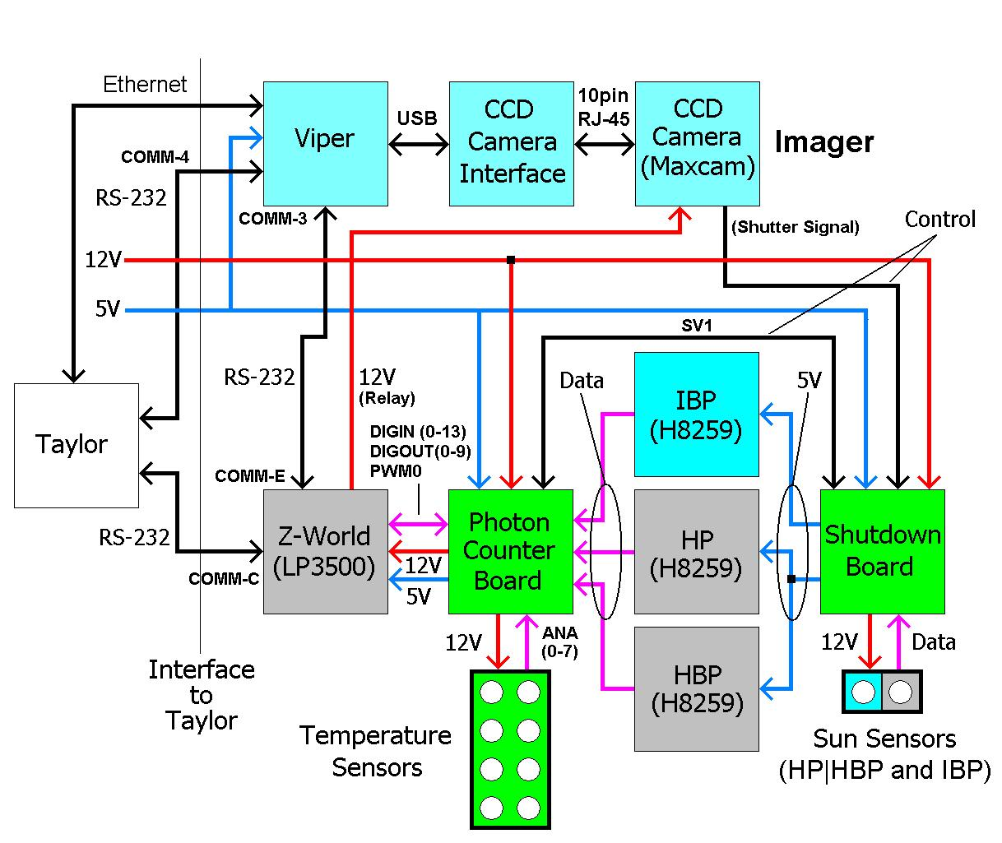
Figure A.1 Electrical Connections
  - Viper PC-104 Single-Board Computer

The Viper interfaces several devices in the instrument. Figure A.2 illustrates the connections made on the Viper.
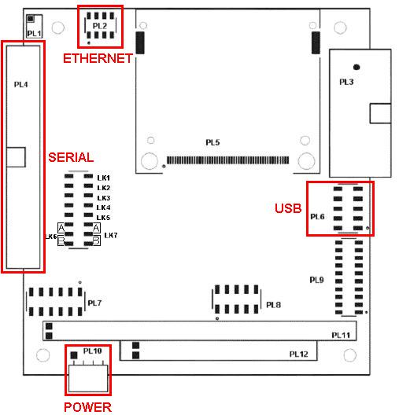
Figure A.2 Viper pin headers
    - Power

Power is supplied to header PL10 by pins 19 and 20 from the Taylor interface connector.
    - USB

The USB connection is routed from header PL6 to the camera interface board.
    - Ethernet

Table A.1 lists the Ethernet connections made with the Taylor interface connector.

Table A.1 Viper Ethernet connections
Viper  Header PL2 |  | Destination
Pin | Function | Header | Pin
1 | TX+ | Taylor interface connector | 14
2 | TX- | Taylor interface connector | 15
3 | RX+ | Taylor interface connector | 17
6 | RX- | Taylor interface connector | 18
8 | Ground | Taylor interface connector | 16

    - RS-232 COM ports

Table A.2 lists the serial connections made by the Viper to the LP3500 and the Taylor interface connector.
Table A.2 Viper rs-232 com port connections
Viper  Header PL4 |  | Destination
Pin | Function | Board | Header | Pin
10 | Ground | Taylor interface connector |  | 6
11 | TX4 | Taylor interface connector |  | 5
12 | RX4 | Taylor interface connector |  | 4
19 | Ground | Photon counter board | COMM | 3
23 | RX3 | Photon counter board | COMM | 2
25 | TX3 | Photon counter board | COMM | 1

  - Z-World LP3500

Figure A.3 illustrates the connections made on the LP3500.
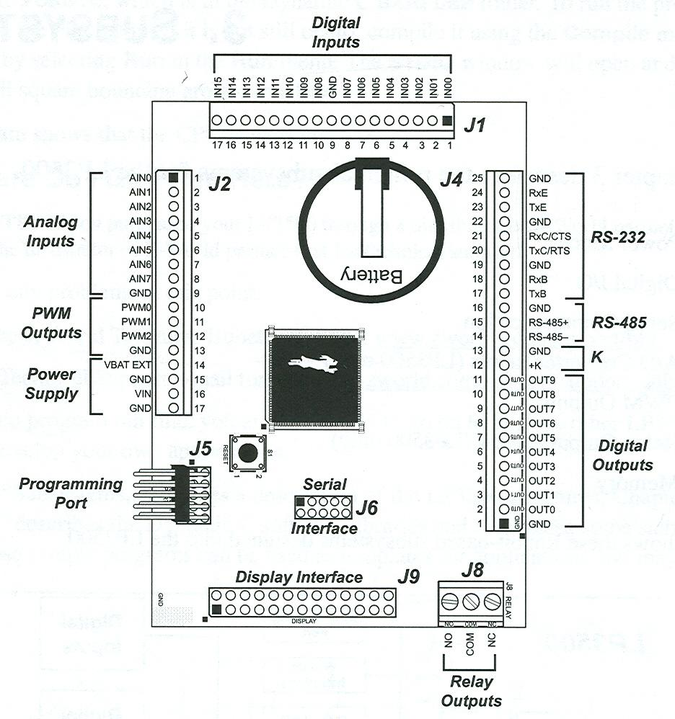
Figure A.3 Z-World LP3500 pin headers
    - Digital input pin definitions

Table A.3 lists the connections made to the digital inputs of the LP3500 by the photometer interface board.
Table A.3 Photometer interface board digital input connections
LP3500 Header J1 | Photon Counter Board Header "DIGIN"
Pin | Schematic Label | Pin | Signal
1 (DIGIN 0) | TIMER | 1 | PWM 3.6 kHz interrupt signal
2 (DIGIN 1) | IBP_OPAMP_OUT | 2 | State of IBP photodiode
3 (DIGIN 2) | QA | 3 | Bit 1 of 8-bit count data bus
4 (DIGIN 3) | QB | 4 | Bit 2 of 8-bit count data bus
5 (DIGIN 4) | QC | 5 | Bit 3 of 8-bit count data bus
6 (DIGIN 5) | QD | 6 | Bit 4 of 8-bit count data bus
7 (DIGIN 6) | QE | 7 | Bit 5 of 8-bit count data bus
8 (DIGIN 7) | QF | 8 | Bit 6 of 8-bit count data bus
9 | GND | 9 | Power ground
10 (DIGIN 8) | QG | 10 | Bit 7 of 8-bit count data bus
11 (DIGIN 9) | QH | 11 | Bit 8 of 8-bit count data bus
12 (DIGIN 10) | IBP_RCO | 12 | IBP count ripple carry out
13 (DIGIN 11) | HP_RCO | 13 | HP count ripple carry out
14 (DIGIN 12) | HBP_RCO | 14 | HBP count ripple carry out
15 (DIGIN 13) | H(B)P_OPAMP_OUT | 15 | State of H(B)P photodiode

    - Digital output pin definitions

Table A.4 lists the connections made to the digital outputs of the LP3500 by the photometer interface board.
Table A.4 Photometer interface board digital output connections
LP3500 Header J4 | Photon Counter Board Header "DIGOUT"
Pin | Schematic Label | Pin | Signal
1 | GND | 1 | Power ground
2 (DIGOUT 0) | ZA | 2 | Selector signal 'A'
3 (DIGOUT 1) | ZB | 3 | Selector signal 'B'
4 (DIGOUT 2) | ZC | 4 | Selector signal 'C'
5 (DIGOUT 3) | ZD | 5 | Selector signal 'D'
6 (DIGOUT 4) | ZCCKEN | 6 | HP and HBP counter clock enable
7 (DIGOUT 5) | ZPOW | 7 | Power relay control
8 (DIGOUT 6) | IBP_DIODE_OVERRIDE | 8 | Override IBP photodiode signal
9 (DIGOUT 7) | H(B)P_DIODE_OVERRIDE | 9 | Override H(B)P photodiode signal
10 (DIGOUT 8) | IBP_ENABLE | 10 | IBP diode active/power off signal
11 (DIGOUT 9) | H(B)P_ENABLE | 11 | H(B)P diode active/power off signal
12 | 5VS | 12 | 5V power to LP3500
13 | GND | 13 | Power ground
    - Thermistor A/D and PWM pin definitions

Table A.5 lists the connections made by the thermistors and the PWM signal of the LP3500 to the photometer interface board.
Table A.5 Photometer interface board analog input and PWM connections
LP3500 Header J2 | Photon Counter Board ANALOG_AND_PWM Header
Pin | Schematic Label | Pin | Signal
1 (ANA 0) | TEMP1 | 1 | Thermistor voltage 1
2 (ANA 1) | TEMP2 | 2 | Thermistor voltage 2
3 (ANA 2) | TEMP3 | 3 | Thermistor voltage 3
4 (ANA 3) | TEMP4 | 4 | Thermistor voltage 4
5 (ANA 4) | TEMP5 | 5 | Thermistor voltage 5
6 (ANA 5) | TEMP6 | 6 | Thermistor voltage 6
7 (ANA 6) | TEMP7 | 7 | Thermistor voltage 7
8 (ANA 7) | TEMP8 | 8 | Thermistor voltage 8
9 | GND | 9 | Power ground
10 (PWM 0) | PWM0 | 10 | Counter 3.6 kHz reference signal

    - RS-232 pin definitions

Table A.6 lists the connections made to the serial ports of the LP3500 by the photometer interface board.
Table A.6 Photometer interface board serial connections
LP3500 Header J4 | Photon Counter Board COMM Header
Pin | Schematic Label | Pin | Signal
20 | TXC | 1 | Serial port 'C' transmit line
21 | RXC | 2 | Serial port 'C' receive line
22 | GND | 3 | Power ground
23 | TXE | 4 | Serial port 'E' transmit line
24 | RXE | 5 | Serial port 'E' receive line

    - Photometer interface board external connector pin definitions

Table A.7 lists the connections made to the Taylor interface connector, Viper, and Shutdown Board by the external header on the photometer interface board.
    - Shutdown board

Table A.8 lists the connections made to the shutdown board.
Table A.7 Photometer interface board connections to external header
Photon Counter Board  External Connector Header |  | Destination
Pin | Schematic Label | Board | Header |  | Pin
17 | TXC | Taylor interface connector |  |  | 8
18 | RXC | Taylor interface connector |  |  | 7
19 | GND | Taylor interface connector |  |  | 9
20 | GND | Viper |  | GND | 29
21 | TXE | Viper |  | COM4 RX | 23
22 | RXE | Viper |  | COM4 TX | 25
23 | GND | Photon counter board |  | SV1 | -
24 | H(B)P_ENABLE | Photon counter board |  | SV1 | 4
25 | 5VS | Photon counter board |  | SV1 | -
26 | H(B)P_DIODE_OVERRIDE | Photon counter board |  | SV1 | 2
27 | GND | Photon counter board |  | SV1 | -
28 | H(B)P_OPAMP_OUT | Photon counter board |  | SV1 | 6
29 | GND | Photon counter board |  | SV1 | -
30 | IBP_ENABLE | Photon counter board |  | SV1 | 10
31 | 5VS | Photon counter board |  | SV1 | -
32 | IBP_DIODE_OVERRIDE | Photon counter board |  | SV1 | 8
33 | GND | Photon counter board |  | SV1 | -
34 | IBP_OPAMP_OUT | Photon counter board |  | SV1 | 12
35 | VIPER_CCKEN_EXT | Photon counter board |  | SV1 | 17
36 | VIPER_RCK_EXT | Photon counter board |  | SV1 | 19

Table A.8 Shutdown board external header pin layout
Header SVI |  | External Connection
Label | Pin | External Connection
5V_IBP | 1 | IBP power supply, 5V power pin
GND | 3 | IBP power supply, ground pin
5V_HBP | 5 | HBP power supply, 5V power pin
GND | 7 | HBP power supply, ground pin
5V_HP | 9 | HP power supply, 5V power pin
GND | 11 | HP power supply, ground pin
H(B)P_DIODE_OUT | 13 | (-) Terminal of HP and HBP photodiode
5VS | 15 | (+) Terminal of HP and HBP photodiode
VIPER_CLK_EXT | 17 | Photon counter board, SV2, pin 36
VIPER_CLK_EXT | 19 | Photon counter board, SV2, pin 35
H(B)P_DIODE_OVERRIDE | 2 | Photon counter board, DIGOUT, Pin 9
H(B)P_ENABLE | 4 | Photon counter board, DIGOUT, Pin 11
H(B)P_OPAMP_OUT | 6 | Photon counter board, DIGIN, Pin 15
IBP_DIODE_OVERRIDE | 8 | Photon counter board, DIGOUT, Pin 8
IBP_ENABLE | 10 | Photon counter board, DIGOUT, Pin 10
IBP_OPAMP_OUT | 12 | Photon counter board, DIGIN, Pin 2
IBP_DIODE_OUT | 14 | (-) Terminal of IBP photodiode
5VS | 16 | (+) Terminal of IBP photodiode
12VS | 18 | 12-V Power supply
CAMERA_SHUTTER | 20 | (-) Terminal of CCD camera shutter control

Control and Data File Formats

Files are used by all imaging systems in the instrument. There are two general types of files employed: control and data. Control files outline the operation of each detector and are communicated to the instrument on a sporadic basis from the ground. Data files store data acquired either by a detector or by errors generated by code executing on any of the processors and are communicated to the ground on at the end of each active region.
Table B.9 lists the pertinent files employed on the system.
Table B.9 Files used by instrument
System | File | Type | File Name as Saved on Computer
Imager | Keogram Exposures | Data | See keogram image file section
Imager | Full-Frame Exposures | Data | See full-frame image file section
Imager | Operational Log | Data | /root/TEST/data/operation_log.text
Imager | Control | Control | /root/TEST/text/control.text
Imager | Command | Control | /root/TEST/text/command.text
Imager | Imager Orbital Times | Control | /root/TEST/text/imager_orbital_times.text
Imager | Full-Frame Image Time | Control | /root/TEST/text/ffimages.text
Imager | IBP background Counts | Data | /root/TEST/data/count_file.text
HP | HP and HBP Counts | Data | 1 (files are named as numbers)
HP | Operational Log | Data | 0 (")
HP | HP Orbital Times | Control | 2 (")
HP | Control | Control | 3 (")

There is one major difference between files stored on the Viper and files stored on the LP3500. The Viper runs on an embedded version of Linux. Files are stored on the Viper as they would on any other computer, with directories and long string names. The LP3500, on the other hand, does not have an operating system. It uses a much more primitive file system without directories or conventional file names; files are named after numbers ranging from 0-255.

  - Imager
    - Data files
      - Operation log

The operation log is a text file detailing events and the time of their occurrence. Lines within the file are produced, for the most part, by errors occurring during the execution of code on the Viper. An example line within the operation log might read:

(write_background_counts_to_file): could not open count file 1234567890

This states that the program write_background_counts_to_file() was unable to open the file associated with the background counts of the IBP. The error occurred 1234567890 seconds after the start of the epoch.
      - IBP background counts

The IBP background counts file is a text file listing the photon events read from the IBP by the photon counter board during the exposure period of each image of the CCD camera. The order they occur in the file corresponds to the order in which each image, keogram or full-frame, was taken by the camera.
      - Full-frame images

Full-frame images are exposures taken from the entire area of the camera CCD array. These files are of type RAW with no image compression. A 16-bit binary number, providing approximately 64 000 shades of gray, represents each pixel. An unbinned full-frame image is composed of 512 x 512 pixels and is 512 kbytes in size. Because of their large size and limited bandwidth for downloading them to the Taylor computer, they will not be taken very often. This mode of operation will be done infrequently for targets of interest, such as auroral zones.

Full-frame image files are named after the time, in seconds and milliseconds, since the beginning of the epoch (January 1st, 1970, 12:00:00am) when the exposure was taken. An example name would appear as follows:

/root/TEST/data/1234567890:23.raw

This image file is located in the /root/TEST/data/ directory on the Viper. The filename states that the image was taken 1 234 567 890 s and 23 ms since the beginning of the epoch.
      - Keogram images

Keogram images are subimage slices taken from full-frame images. Keograms provide brightness vs. elevation angle along the orbital path and will be taken on a periodic basis. Slices over time will be stacked to provide information of spatial structure along the path. This will be the normal mode of operation for the instrument.

Keogram file names are a combination of the time, in seconds and milliseconds, since the beginning of the epoch when the exposure was taken, along with the location on the original full-frame image where the slices were taken, in the form of an upper-left corner and a lower-right corner. An example name appears as follows:

/root/TEST/data/1234567890:23-0:0-20:20.raw

The image file is located in the /root/TEST/data/ directory on the Viper. The filename states that the image was taken 1 234 567 890 s and 23 ms since the beginning of the epoch and corresponds to the rectangular area outlined by upper-left coordinate (0, 0) and bottom-right coordinate (20, 20) on the original full-frame image.
    - Control files
      - Full-frame image file

The full-frame image control file is a text file that details the operation of the CCD camera with respect to full-frame images. Each line within the file refers to one exposure and is broken up into the five parts listed below:
- Exposure time in seconds since the beginning of the epoch.
- Milliseconds portion of time (0-999).
- Exposure period (time shutter is open during exposure) in seconds (0-999).
- Horizontal binning (0-999, though camera is limited to a maximum bin of 16).
- Vertical binning (0-999, though camera is limited to a maximum bin of 16).

Table B.10 gives the format for each line of a full-frame image file.
Table B.10 Format of each line in a full-frame image file
Exposure time  (in seconds since the Epoch) |  |  |  |  |  |  |  |  |  | Exposure time  (seconds) |  |  | Exposure Period  (seconds) |  |  | Binning  (X) |  |  | Binning  (Y)
x | x | x | x | x | x | x | x | x | x | x | x | x | x | x | x | x | x | x | x | x | x

A sample line in a full-frame image file might appear as follows:

1079304904677002001005

This line states that a full-frame exposure will occur at 1 079 304 904 s and
677 ms since the start of the epoch. The exposure period is 2 s, the horizontal binning is 1 (indicating no binning), and the vertical binning is 5.
      - Command file

Command files are text files that specify Unix system commands for the Viper to execute after the file has been downloaded. The commands are listed in order of execution. Command files exist only for the Imager because an operating system is required for it to work, and the Viper is the only computer in the entire instrument that has one. A sample command file might appear as follows:

ls -al
pwd
ps

The first command displays the contents of the current directory in long format. The second command displays the current working directory. The third command lists the processes currently executing on the computer.
      - Orbital times file

Orbital times files are text files that list the time, in seconds and milliseconds, since the beginning of the epoch when the Imager enters each active and inactive orbital region.

Odd lines are transition times into active regions; even lines are transition times into inactive regions.

Table B.11 gives the format for each line of an orbital times file.
Table B.11 Format of a line in a orbital times file
Orbital transition time  (in seconds since the Epoch) |  |  |  |  |  |  |  |  |  | Orbital transition time  (msec.)
x | x | x | x | x | x | x | x | x | x | x | x | x

Following are what two lines from an orbital times file might look like:

(lines 1-3)
1073364000050 (line 4)
1073364050070 (line 5)
(lines 6-??)

The first line, because it exists on an even line, lists the time when the Imager enters an inactive region. This transition occurs at 1 073 364 000 s and 50 ms since the start of the epoch.

The second line, because it exists on an odd line, specifies the time when the Imager enters an active region. This transition occurs at 1 073 364 050 s and 20 ms after the start of the epoch, or about 50 s since the last inactive transition. Thus, the inactive region is about 50 s long (not a realistic value, but just an example for illustration purposes).
      - Control file

Control files are text files that provide operational instructions to the Imager on how to take keogram exposures. They outline the period of each exposure, the exposure time, binning, and the locations in each full-frame image to take the slices. Table B.12 gives the format for each line of a control file.

Table B.12 Imager control file specifications
Line | Attribute
1 | Delay (in seconds) from beginning of active region, to take first keogram image
2 | Delay (in milliseconds) from beginning of active region, to take first keogram image
3 | Delay (in seconds) between keogram exposures
4 | Delay (in milliseconds) between keogram exposures
5 | Exposure time (in milliseconds) of each keogram
6 | Horizontal (X) binning of keograms
7 | Vertical (Y) binning of keograms
8 | Coordinates to take keogram slice. The coordinates outline the upper left and lower right corners of a rectangle encompassing the keogram slice.
… | Additional keogram slice coordinates…

Following is what a sample control file might look like:

5 (line 1)
100 (line 2)
10 (line 3)
50 (line 4)
1000 (line 5)
10 (line 6)
1 (line 7)
0, 0, 10, 511 (line 8)
……… (lines 9-??)
Following is an explanation of the file:

- Lines 1-2: 5 s and 100 ms delay from beginning of active region to take first keogram.
- Lines 3-4: 10 s and 50 ms period between keogram exposures.
- Line 5: camera exposure period of 1 s (1000 ms).
- Line 6: 10x horizontal binning.
- Line 7: 1x vertical binning (essentially not binned).
- Line 8: keogram slice to be taken within the rectangle whose upper-left coordinate is 0,0 and lower-right coordinate is 10, 511. Additional keogram slices would be listed in lines 9 through the end of the file.

  - Hertzberg Photometer
    - Data files
      - Operation log

The operation log is a text file detailing events and the time of their occurrence. Lines within the file are produced, for the most part, by errors occurring during the execution of

code on the LP3500. The format is the same as that for the Imager.
      - HP and HBP counts

The HP and HBP counts file is a text file listing the photon events read from the HP and HBP by the photon counter board, along with temperature readings of temperature-sensitive components throughout the instrument. The format of this file is still being worked out, but each line within the file will follow the general template of Table B.13.
Table B.13 HP and HBP counts file line template
Photometer Count Values |  |  | Temperature Readings |  |  |  |  |  |  |  | Time-stamp
1 | 2 | 3 |  | 4 | 5 | 6 | 7 | 8 | 9 | 10 | 11

Following is how Table B.13 is broken down:

Photometer count values
1: HP count value.
2: HBP count value.

Temperature readings
3: Camera filter temperature.
4 IBP filter temperature.
5: IBP photomultiplier tube temperature.
6: HBP photomultiplier tube temperature.
7: HP photomultiplier tube temperature.
8: Not yet defined (thermistor not yet installed).
9: Not yet defined (thermistor not yet installed).
10: Not yet defined (thermistor not yet installed).

Timestamp
11: Time of measurement, in seconds and milliseconds, since the epoch.

The final format of the file will be designed to minimize the file size as much as possible. This is because there is only about 500 kbytes of memory available for data storage on the LP3500.
    - Control files
      - Orbital times file

Orbital times files are text files that list the time, in seconds and milliseconds since the epoch, when the HP enters each active and inactive orbital region. The format is the same as that for the Imager.
      - Control file

Control files are text files that provide operational instructions to the LP3500 on how to operate the photometers. They outline the integration time and power management of the HP, HBP, and IBP. Table B.14 gives the format for each line of a control file.
Table B.14 HP, HBP, and IBP control file specifications
Line | Attribute
1 | HP and HBP photometer integration time
2 | HP and HBP photometer power state: photodiode activated (0), always on (1), or always off (2)
3 | HP and HBP photometer wait time until reactivation after shutoff
4 | IBP photometer power state: photodiode activated (0), always on (1), or always off (2)
5 | IBP photometer wait time until reactivation after shutoff

Following is what a sample control file might look like:

3600 (line 1)
1 (line 2)
10 (line 3)
2 (line 4)
10 (line 5)

Following is how to interpret the file:
- Lines 1: 1-s integration time for the HP and HBP (PWM signal has a frequency of
3.6 kHz, so 1 s of integration equals 3600 pulses). The integration time for the IBP is the same as the exposure period of the Imager camera.
- Lines 2: Power state 1 - the HP and HBP are to remain on throughout the active region, regardless of the state of the photodiode associated with them. The photometers are turned off when the HP and HBP enters the inactive orbital region.
- Line 3: If line 2 was photodiode activated, the HP and HBP photometer would remain off for 10 s from the last occurrence of the photodiode being deactivated after having been previously activated by excessive sunlight. This is done to ride out any potential "bounce" in the signal coming off the solar sensor. This specification will have no effect because the photometers are to be kept always on by line 2.
- Line 4: Power state 2 - the IBP is to remain off throughout the active region, regardless of the state of its photodiode sun sensor.
- Line 5: Same as line 3, but applied to the IBP instead.

Optical Specifications of Instruments
  - Imager

Table C.15 summarizes the signal and noise properties of the Imager under
200 Rayleighs of light.
Table C.15 Imager optical specifications
Attribute | Value | Unit
Lens Focal Length | 0.050 | m
Lens Area | 1.964E-3 | m²
CCD Pixel Dimension | 4.000E-10 | m²
Lens LGP/Pixel | 3.140E-10 | sr
CCD QE | 0.630 | · 100%
Minimum Light Intensity | 200 | R
Bare CCD | 31.579 | e⁻/pixel·s
Lens + Filter Transmission | 0.7 | · 100%
CCD, Filter | 22.105 | e⁻/pixel·s
CCD Pixel Well | 3.000E5 | e⁻
Digitization | 65 536
e-/ADU | 4.578
CCD Min Readout Pixel Value | 2611
Ave. Readout Pixel Value | 2638
CCD Readout Noise | 27.0
CCD Readout Noise | 123.6 | e⁻

  - IBP

Table C.16 summarizes the signal and noise properties of the IBP under 200 Rayleighs of light.

Table C.16 IBP optical specifications
Attribute | Value | Unit
Lens Focal Length: | 0.025 | m
Lens Diameter: | 6.160E-03 | m
Lens Area | 1.190E-04 | m²
Aperture Diameter: | 0.0035 | m
Aperture Area: | 9.621E-06 | m²
LGP: | 1.777E-06 | sr
Lens Transmission @ 625nm: | 0.9 | · 100%
Filter Transmission @ 625nm: | 0.8 | · 100%
Minimum Light Intensity: | 200 | R
Lens + Filter + Aperture e⁻/s: | 2.042E5 | e⁻/s
e⁻/s Watt @ 625nm: | 3.150E18 | e⁻/W
Power of light: | 0.065 | pW
Photometer Sensitivity: | 30 000 | e⁻/pW/s
Photometer e⁻/s: | 1946.5 | e⁻/s
Dark Current (at 22°C): | 5 | e⁻/s

  - HP and HBP

Table C.17 summarizes the signal and noise properties of the HP and HBP under 200 Rayleighs of light.
Table C.17 HP and HBP optical specifications
Attribute | Value | Unit
Lens Focal Length: | 0.090 | m
Lens Diameter: | 3.750E-02 | m
Lens Area | 4.420E-03 | m²
Aperture Diameter: | 0.003 | m
Aperture Area: | 7.069E-06 | m²
LGP: | 3.855E-06 | sr
Lens Transmission @ 275nm: | 0.9 | · 100%
Filter Transmission @ 275nm: | 0.8 | · 100%
Minimum Light Intensity: | 200 | R
Lens + Filter + Aperture e⁻/s: | 4.429E5 | e⁻/s
e⁻/s Watt @ 275nm: | 3.150E+18 | e⁻/W
Power of light: | 0.141 | pW
Photometer Sensitivity: | 2.100E5 | e⁻/pW/s
Photometer e⁻/s: | 2.956E4 | e⁻/s
Dark Current (at 22°C): | 5 | e⁻/s

POWER PROFILE

Table D.18 lists the voltage, current, and power profile of each component in the instrument, and gives the region where they are active.
Table D.18 Power profile of individual components
Component | Voltage  (V) | Current  (A) | Power  (W) | Region of Orbit
 |  |  |  | Dark | Light
Viper + Camera Interface Board | 5.0 | 0.366 | 1.830 | X | X
CCD Camera | 12.0 | 0.320 | 3.840 | X
IBP | 5.0 | 0.050 | 0.250 | X
Shutdown Board | 5.0 | 0.050 | 0.250 | X
Z-World LP3500 | 5.0 | 0.040 | 0.200 | X | X
Photon Counter Board | 5.0 | 0.350 | 1.750 | X
HP | 5.0 | 0.050 | 0.250 | X
HBP | 5.0 | 0.050 | 0.250 | X
Thermistors | 12.0 | 0.002 | 0.024 | X | X

Table D.19 lists the power draw from each instrument under different operational states.
Table D.19 Power profile of different operational states
Imager Power State | Imager Power  (W) | HP Power State | HP Power  (W) | Total Power  (W)
ON | 5.920 | OFF | 2.224 | 8.144
ON | 5.920 | ON | 2.724 | 8.644
OFF | 1.830 | OFF | 0.224 | 2.054
OFF | 1.830 | ON | 2.724 | 4.554

Notes:
- The photon counter board can be shutdown individually from the Z-World LP3500; however, the current design has a malfunctioning relay. With a functional relay, the board should be shutting down during the light region.
- The Viper and camera interface board are always on.
- The Z-World LP3500 is always on.
- The HP and HBP have coupled power lines.
- The Viper power shown is the default power for the default configuration. The following options can be disabled to save power:
- Put serial ports 1, 2, and 5 to sleep.
- Shutdown USB port 2.
- Run Viper in 100-MHz mode.

Design Documents CD

REFERences

[1] H. D. Voss et al., "A highly modular scientific nanosatellite: TEST," to be presented at the 18th Annual AIAA/USU Conference of Small Satellites, Logan, Utah, August, 2004.

[2] Arcom Development CD, "Viper - RedBoot and Arcom embedded Linux Support," Arcom, 2004.

[3] Z-World User's Manual, Fox (LP3500): C-Programmable Single-Board Computer, Z-World, 2004.

