Thunderstorm Effects in Space: Technology
Design and construction of a Nanosatellite Imaging Instrument to study thunderstorm-induced phenomena in Earth's atmosphere

BY

Matthew Linden Maple

B.S., Portland State University, 2001

THESIS

Submitted in partial fulfillment of the requirements
for the degree of Master of Science in Electrical Engineering
in the Graduate College of the
University of Illinois at Urbana-Champaign, 2004

Urbana, Illinois

Committee approval form goes here.
Acknowledgments

I would like to thank Professor Gary Swenson for his guidance and instruction throughout this project. I would also like to thank NASA and the USAF Office of Space Research for providing the funding and expertise that made this project possible. To all the students, staff, and faculty of the Electro-Optics Systems Laboratory, I am grateful for your kindness and advice during my time in the lab. And lastly, a special thanks to my parents, Paul and Patricia, for always being there for me and encouraging me to reach for my goals in life.
Table of Contents
Page
1. Introduction 1
1.1 Technical Proposal 2
1.1.1 Imager 2
1.1.2 HP 3
1.1.3 Specifications 3
2. The Design 5
2.1 General Overview 5
2.1.1 Instrument components 5
2.1.1.1 Viper 5
2.1.1.2 MaxCam CCD camera and interface board 6
2.1.1.3 Z-World LP3500 and photon counter board 6
2.1.1.4 Shutdown board 7
2.1.1.5 Hamamatsu H8259 photometer 7
2.1.2 Mechanical assembly 8
2.1.2.1 General layout 8
3. Hardware 11
3.1 Imager Camera and Interface Board 11
3.1.1 Interface board and connectors 11
3.1.2 CCD array 12
3.1.3 Mechanical assembly 13
3.1.3.1 Interface board 13
3.1.3.2 Camera 14
3.2 Viper PC-104 Single-Board Computer 14
3.2.1 Specifications 15
3.2.2 Software 15
3.2.3 Mechanical assembly 16
3.3 H8259 Hamamatsu Photometer 17
3.3.1 Count sensitivity and dark current 18
3.3.2 Mechanical assembly 20
3.3.2.1 IBP 20
3.3.2.2 HP and HBP 20
3.4 Photon Counter Board 21
3.4.1 Z-World LP3500 22
3.4.1.1 Specifications 24
3.4.1.2 Mechanical assembly 24
3.4.2 Photometer interface board 25
3.4.2.1 Schematics 26
3.4.2.2 Mechanical assembly 31
3.4.3 Temperature sensors (thermistors) 32
3.5 Shutdown Board 34
3.5.1 Circuit board 35
3.5.1.1 Schematic 35
3.5.1.2 Mechanical assembly 39
3.5.2 Sun sensors 40
3.5.2.1 Specifications 41
3.5.2.2 Mechanical assembly 42
3.6 Imager, IBP, HP, and HBP Lens and Filter Assemblies 46
3.6.1 Lenses 47
3.6.2 Filters 50
3.6.2.1 Imager 50
3.6.2.2 IBP 51
3.6.2.3 HP 51
3.6.2.4 HBP 52
3.6.3 Mechanical assemblies 52
3.6.3.1 Imager 52
3.6.3.2 IBP 53
3.6.3.3 HP and HBP 53
3.7 Taylor Interface Connector 55
3.7.1 Pin specifications 55
3.7.2 Mechanical assembly 55
4. Operation 57
4.1 Signal-to-Noise Ratio 57
4.1.1 Imager 58
4.1.2 IBP 62
4.1.3 HP and HBP 63
4.2 Communication 64
4.2.1 Command communication 65
4.2.1.1 write_raw() 66
4.2.1.2 check_for_command() 66
4.2.1.3 read_raw() 66
4.2.2 File communication 67
4.3 Software 67
4.3.1 Imager 67
4.3.1.1 Operational flowchart explanation 68
4.3.2 HP and HBP 72
4.3.2.1 Operational flowchart explanation 73
5. Conclusion 79
5.1 What Has Been Accomplished 79
5.2 What Still Needs to be Done 80

Introduction

Approximately 2000 thunderstorms are active near the Earth’s surface at any given time, and on average, lightning strikes the Earth ~100 times/s [1]. The average discharge radiates an intense electromagnetic pulse of ~20 GW peak power that propagates through the lower atmosphere and into the ionosphere and magnetosphere. This energy source can produce significant variations in the Earth’s global electric circuit and is a consideration in communications as well as phase effects on GPS transmissions from satellites.

Thunderstorms can also produce large atmospheric movements that can launch upper atmospheric gravity waves (AGWs) and produce wave activity such as traveling ionosphere disturbances (TIDs). AGWs influence mean flow circulations in the mesosphere and lower thermosphere and are a major engineering consideration for aerodynamic re-entry vehicles as well as aerobraking in the 80-110 km altitude region of the earth's atmosphere.

No comprehensive satellite has yet been undertaken to fully elucidate the global coupling of thunderstorm energy into the space environment. The Nanosat3 competition hosted by the Air Force Office of Space Research (AFOSR) and NASA provided an opportunity for the University of Illinois, in conjunction with Taylor University (Upland, Indiana), to participate in the construction of a small satellite to investigate these phenomena in detail. The result was the Thunderstorm Effects in Space: Technology (TEST) nanosatellite. As part of a larger package of in-situ and remote sensing scientific instruments onboard TEST, the University of Illinois designed, built, and tested two major instruments: a UV Hertzberg Photometer (HP) and a 630-nm CCD Imager (Imager). The objective of these two instruments is to better understand the sources and propagation of AGWs into the space environment, thunderstorm coupling to the ionosphere, and lightning-induced electron participation into the radiation belt.
  - Technical Proposal

Figure 1.1 depicts the operation and specifications of both the Imager and HP.
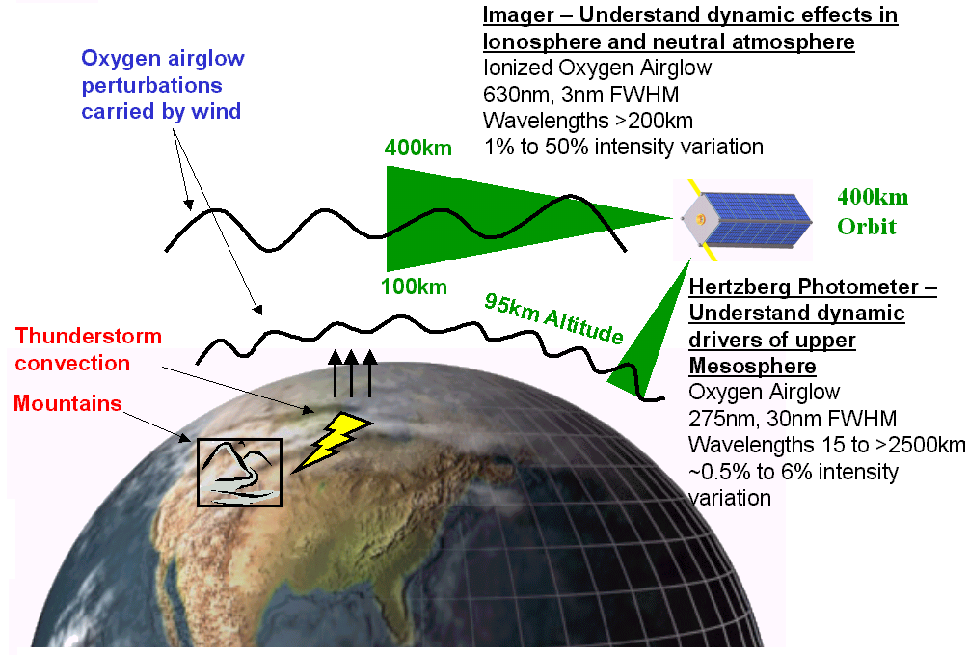
Figure 1.1 Operation of the instrument
    - Imager

The Imager will point at the limb of the Earth and study irregularities in ionospheric electron densities caused by AGWs. It will measure ionized oxygen airglow perturbations in the 630-nm spectral region between altitudes of 100 km and 400 km. Target intensity wavelengths are expected to be greater than 200 km with brightness ranging from 200 to 700 Rayleighs.

The Imager will include an off-channel background photometer, called the Imager background photometer (IBP), to separately measure background light. Measurements from the IBP will be subtracted on the ground from those of the Imager to highlight the airglow variations of interest. The IBP is protected from excessive light by a photodiode controlled shutdown circuit.

The camera will have two modes of operation: keogram or full frame. Keogram mode involves taking just a central slice of the image plane to give brightness vs. elevation angle information. Slices over time will be stacked to provide information of spatial structure along the orbital path. Full frame mode involves taking a complete picture of the image plane. Keogram mode will be the normal operating mode of the instrument; full-frame mode will occur infrequently for targets of interest, such as auroral zones.

Each instrument integrates for about 8-10 s in order to give the Imager a
signal-to-noise ratio (SNR) above 50, and the IBP an SNR above 100. Their field of view is about 8°, covering the altitudes of interest from a low-Earth orbit.
    - HP

The HP will point in the nadir direction and will study the intensity of the O₂ Hertzberg bands in the 260-290 nm spectral region. These emissions originate at about 98 km, the peak altitude of atomic oxygen density, and are shielded from lower atmospheric emissions by ozone absorption in the stratosphere.

Like the Imager, the HP will include an off-channel background photometer, called the Hertzberg background photometer (HBP), to separately measure background light. Measurements from the HBP will be subtracted from those of the HP on the ground to highlight the airglow variations of interest. Both photometers will be protected from excessive light by a photodiode controlled shutdown circuit.

The HP and HBP will integrate for about 1 s in order to provide each with an SNR greater than 100. Their field of view is approximately 2°, covering about 8 km on the ground from a low Earth orbit, equivalent to the distance traveled by the satellite during one integration period.
    - Specifications

Table 1.1 summarizes the general specifications of the Imager, IBP, HP, and HBP.

Table 1.1 Instrument specifications
Instrument | Specification | Value
Imager | SNR | >50
Imager | FOV | 8 º
Imager | Spectral Range | 630 nm, 3 nm FWHM
Imager | Source Intensity | (200 R to 700 R) + 6 kR Background
Imager | Pixel Array Size | 512 x 512 pixels
Imager | Integration Time | >10 s
Imager | Inclination | 78 ° off normal
IBP | SNR | >50
IBP | FOV | 8 º
IBP | Spectral Range | 625 nm, 3 nm FWHM
IBP | Integration Time | Same as Imager
IBP | Inclination | Same direction as Imager
HP | SNR | >100
HP | FOV | 2 º
HP | Spectral Range | O2 Hertzberg band 260-290 nm
HP | Source Intensity | (500 R to 1500 R) + 5 R of Background
HP | Integration Time | 1 s
HP | Inclination | 12 ° off normal
HBP | SNR | >100
HBP | FOV | 2 º
HBP | Spectral Range | 225 to 255 nm
HBP | Source Intensity | > 5 Rayleighs
HBP | Integration Time | Same as HP
HBP | Inclination | Same direction as HP

The Design
  - General Overview

Figure 2.2 illustrates the basic design of the instrument. Blue boxes represent hardware belonging to the Imager, gray boxes represent hardware belonging to the HP and HBP, and green boxes represent hardware shared by both instruments.
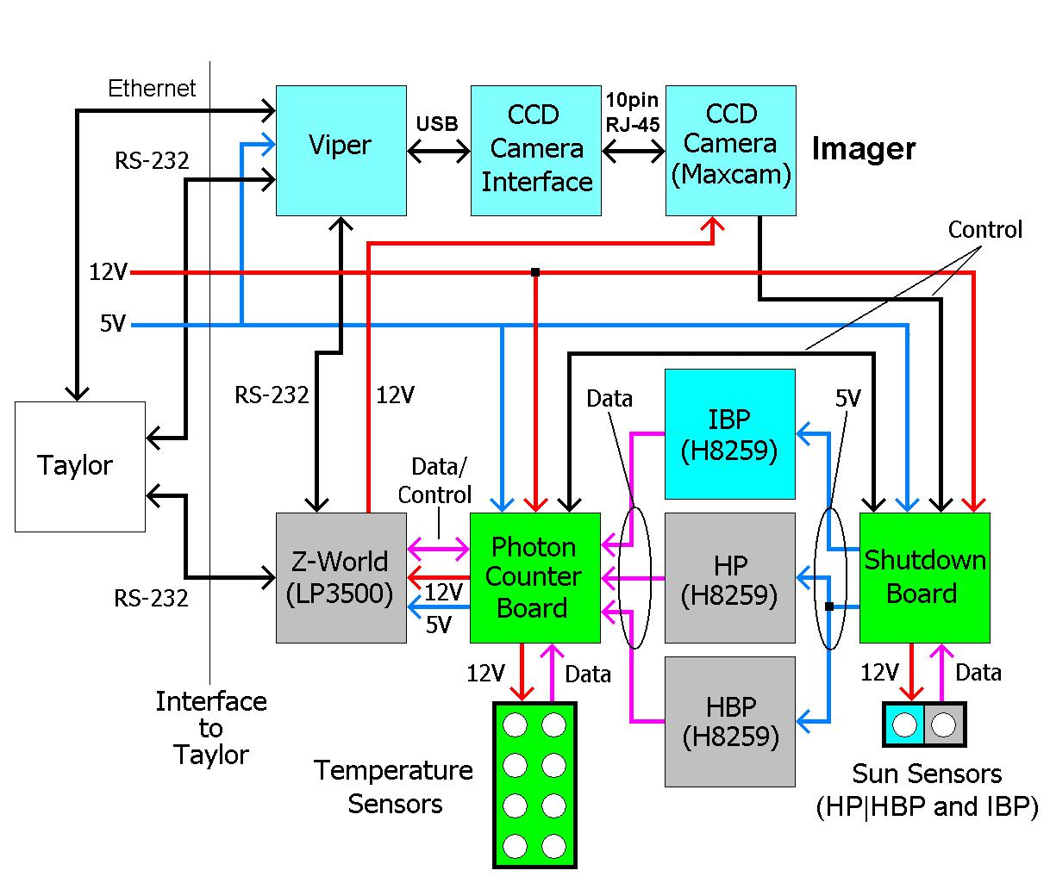
Figure 2.2 System diagram
    - Instrument components
      - Viper

The Viper computer provides imager command and control. The Viper is an ultra-low-power PC-104 compatible single board computer based on the Intel® 400MHz PXA255 XScale™ RISC processor. It operates under an embedded version of RedHat Linux. The Viper operates the Imager camera and, in an indirect fashion, the IBP. Control files stored on the Viper specify the operation of both instruments and are uploaded to the Viper on a periodic basis across an RS-232 line from the Taylor computer. Data files generated by the camera and the IBP are stored on the Viper as they are created and are uploaded across the same serial line to the Taylor computer at the end of every active region of orbit.
      - MaxCam CCD camera and interface board

The Imager sensing instrument is a Finger Lakes MaxCam CCD camera based on a Kodak 512 x 512 KAF0261 CCD array with a pixel feature size of 20 μm. Cooling is provided by a cold finger that attaches to the back of the CCD array housing. The camera will operate primarily in keogram mode, taking slices from full-frame images in the horizontal and vertical direction on a periodic basis along the orbital path. Full-frame images will be taken only sparingly because each image is over a half-megabyte in size and can quickly overwhelm the bandwidth limitations imposed by the communication link to the ground. The Viper interfaces to the camera through the CCD camera interface board. The board connects to the Viper by a USB cable on one end and to the camera by a 10-pin RJ-45 cable on the other. Power for the board is provided by the USB connection; power for the camera is provided by a relay onboard the Z-World LP3500 microcontroller attached to the photon counter board.
      - Z-World LP3500 and photon counter board

The photon counter board is a custom-designed board that counts pulses coming off each photometer and relay the counts to a Z-World LP3500 microcontroller plugged into the board. Control files stored on the LP3500 specify the operation of the HP and HBP photometers and are uploaded to the LP3500 on a periodic basis across an RS-232 line from the Taylor computer. The IBP counter chips are controlled by a camera signal routed through the shutdown board and onto the photon counter board. Photon count files generated by the HP and HBP are communicated directly to the Taylor computer at the end of both the HP and IBP active periods. Counts from the IBP are communicated back to the Viper after each integration cycle. Temperature information of critical components is fed to the photon counter board by eight thermistors. These are read in by the LP3500 and stored alongside the counts read off the photometers. The board also interfaces to the other custom designed board, the photometer shutdown board, to provide control over the power states of each photometer.
      - Shutdown board

The shutdown board is a custom designed board that provides protection against excessive light striking the photometers. It interfaces with two photodiode imaging systems; one for the IBP and the other for the HP and HBP. Light striking the photodiodes produces a voltage that, if greater than a threshold set on the shutdown board, turns off the photometer(s) associated with that particular photodiode. The LP3500 can read the states of the photodiodes off the board and send signals to re-activate any of the photometers.

The board also serves as an interface between the CCD camera shutter signal and the IBP counters on the photon counter board. A signal from the shutter of the camera routes to an interface subcircuit on the board, and from there to the photon counter board, where it drives the counter chips associated with the IBP. The purpose of this signal is to synchronize counting of pulses off the photometer with exposures on the Imager camera.
      - Hamamatsu H8259 photometer

The IBP, HP, and HBP are Hamamatsu H8259 photometers. Each generates a square wave of a specific width and amplitude in proportion to each photon striking the photomultiplier tube at a given wavelength. The integration time of the HP and HBP photometers will be 1 s. The IBP, on the other hand, will operate only during the exposure period of the camera, or about 8-10 s. All three photometers interface the photon counter board by coaxial cables.
    - Mechanical assembly

Modularity was a major theme of the TEST nanosatellite. It was agreed upon early on to standardize the dimensions of each instrument by requiring them to be in units of a smaller box size associated with a cubesat project at Taylor University, TU Sat 1. Our instrument box corresponds to a 2 x 3 x 1 TU Sat 1 cubesat lattice, or
31cm x 20.5cm x 10cm. Figure 2.3 is a photograph of the structure.
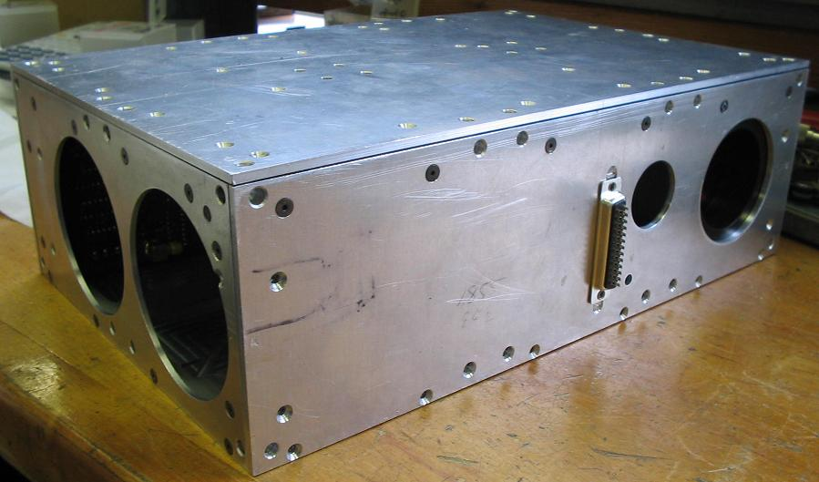
Figure 2.3 Mechanical structure of the instrument

The structure attaches to the superstructure of the satellite by dowel pins secured to holes spaced at evenly placed locations around the instrument box. Five of the six walls were designed as secondary load-bearing supports and were built with 1/8-in aluminum plates; the sixth wall (in contact with the table top) is the primary load-bearing support (optical bench) that every instrument secures to and is built from sturdier 1/4-in milled aluminum. The walls of the structure are held together by tapered screws that lie flush with the outer surface.
      - General layout

Figure 2.4 illustrates the internal layout of the instrument. The photo looks down on the instrument with the top removed. The Imager and IBP face downward and the H(B)P faces left. All of the circuit boards are in the back of the instrument (top of the image) except for the shutdown board, which fits within the gap formed by the three photometers. Not shown in the picture is the LP3500. It is located next to the photon counter board below a bracket running along the inside of the instrument box. Wires attached to the temperature sensors can be seen coming out of the Imager and IBP lens tubes, and in the crevice where the shutdown board is located. This picture was taken when the instrument was fresh out of the machine shop and the components were not wired together.
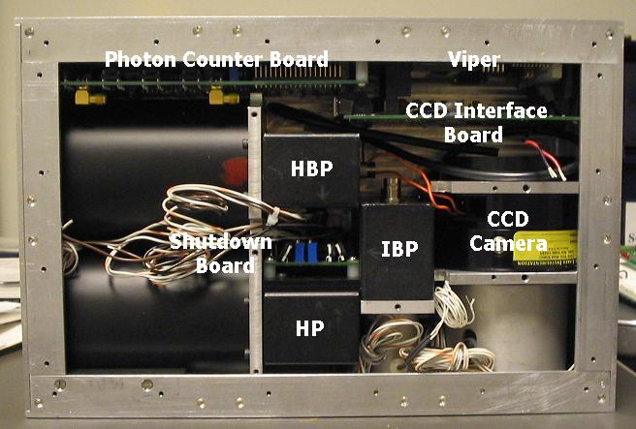
Figure 2.4 Location of components inside the instrument box

Imager and IBP

Figure 2.5 is a picture of the Imager side of the instrument. All instrument holes cut into this panel were required to be on the right half because solar cells that power the spacecraft will cover the section to the left. The instrument interfaces to the Taylor computer through the 25-pin sub-D female connector seen in the middle of the panel.
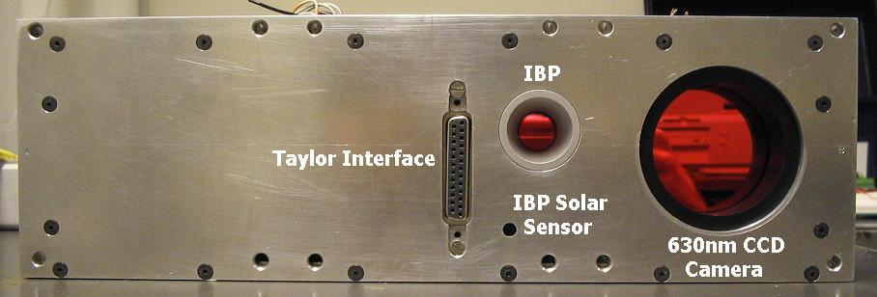
Figure 2.5 Imager side of the instrument looking from the front

HP and HBP

Figure 2.6 shows the HP and HBP side of the instrument. The notable features of this picture are the two 3-in-diameter fused-silica lenses. Large lenses were needed because the integration time of the HP and HBP is short and their SNR was required to be above 100. Note the absence of filters on the lenses. They are not there because the manufacturer did not deliver them in time for this picture.
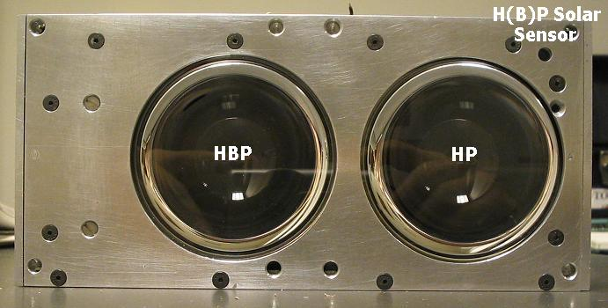
Figure 2.6 HP and HBP side of the instrument looking from the side

Hardware
  - Imager Camera and Interface Board

The Imager detector is a Finger Lakes MaxCam CCD camera. The camera is ruggedly built, yet compact in size and weight. It employs a stainless steel three-vane leaf shutter that can open and close in as little as 0.024 s. Power is provided by a single 12-V supply through a standard speaker plug. The original unit came with a dual stage thermoelectric cooler; however, the flight version does not use it because the fan unit would be useless in the vacuum of space. Instead, it uses a cold finger to make contact with the CCD back mounting plate. Figure 3.7 shows a side view of the MaxCam.
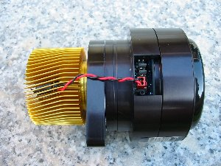
Figure 3.7 Finger Lakes MaxCam CCD camera
    - Interface board and connectors

The Viper operates the camera through an interface board. The interface board is shown in Figure 3.8. The interface board routes all signals between the Viper and camera. The top connector interfaces a 10-pin RJ-45 cable to the side of the CCD camera near the power connector. The middle connector interfaces a USB connector to the Viper. Power is supplied to the board through the USB connector. The third connector on the bottom is not used.
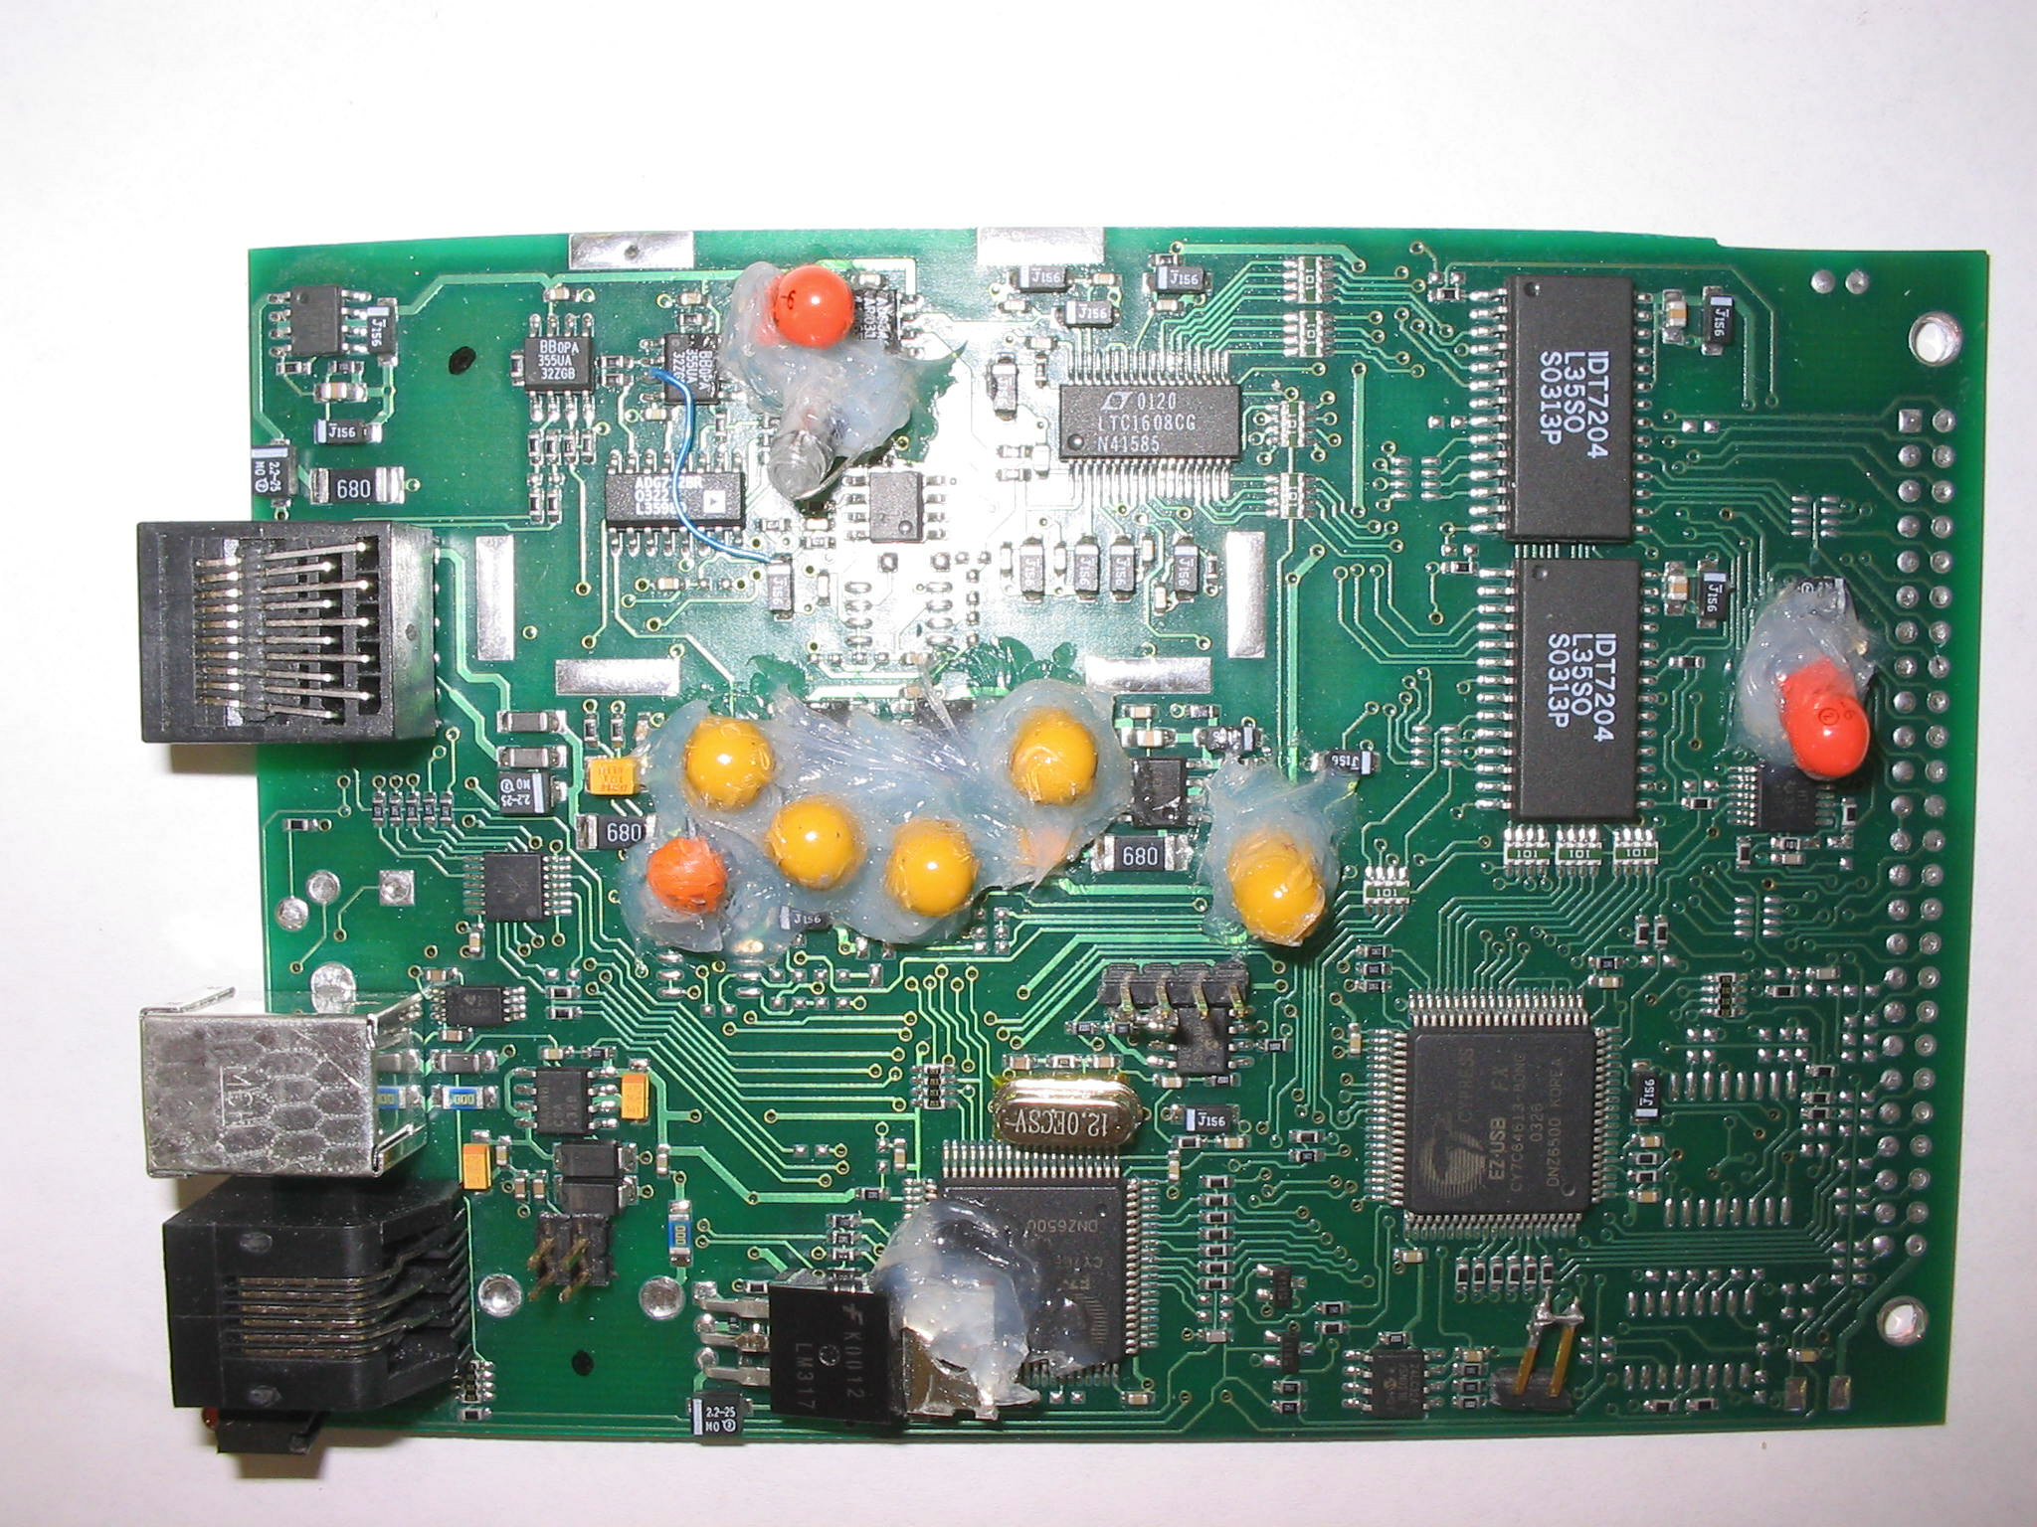
Figure 3.8 Finger Lakes MaxCam interface board

A light-emitting diode (LED) is located near the bottom connector. It lights up if there is a problem with the connection between the interface board and the Viper or camera, or when an image is being downloaded from the camera to the Viper.

The factory default board used electrolytic capacitors. These are not suitable for space environment and were removed and replaced with tantalum capacitors. Silicon was applied to them by the manufacturer to better secure them to the board.
    - CCD array

The camera uses a thinned backside illuminated Kodak KAF0261E CCD array. The chip is located inside a self-contained airtight chamber in the camera. The array size is
512 x 512 and has a pixel feature size of 20 μm. Each pixel has an electron well depth of about 500 000 electrons. The peak quantum efficiency is about 68% at 600 nm, roughly the same wavelength as the Imager filter (630 nm). The quantum efficiency of the array across a wide range of wavelengths is illustrated in Figure 3.9.
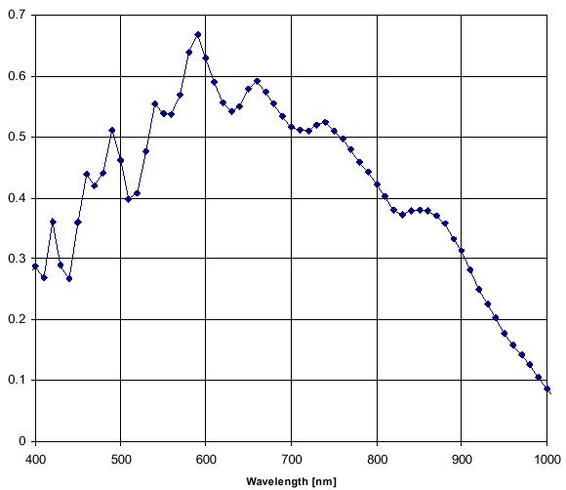
Figure 3.9 Quantum efficiency of Kodak KAF-0261E CCD array
    - Mechanical assembly
      - Interface board

The interface board is located in the back corner of the instrument box, next to the photon counter board. It piggybacks the Viper by four Delrin standoffs. Figure 3.10 shows the interface board inside the instrument box. The edges of the board were milled slightly to make it fit between the top and bottom aluminum panel.
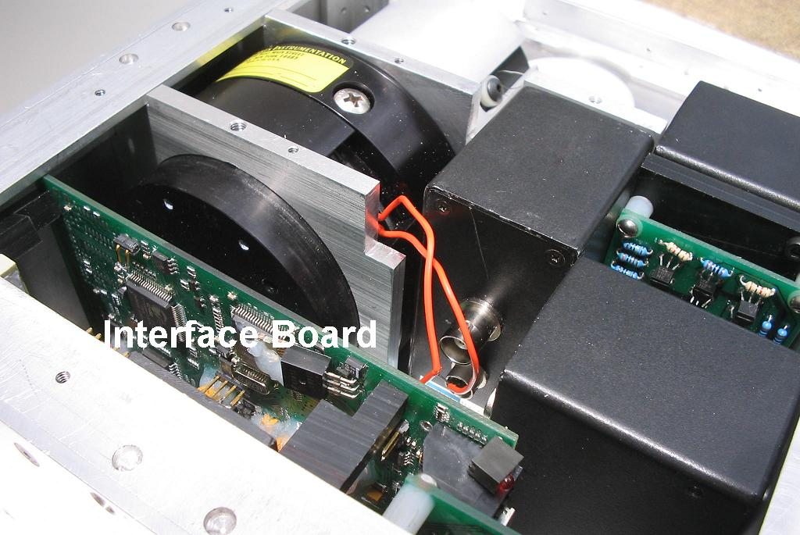
Figure 3.10 Interface board in the instrument box
      - Camera

The camera is located near a side panel of the instrument and faces forward. Figure 3.11 shows the camera inside the instrument box. Two plates fastened to the top, bottom, and side of the instrument box encapsulating the camera. The power and signal connector are at an angle to allow space for cables to attach to them. Notches are cut in the upper corners of the plates to allow passage of cables connecting the various boards and instruments to the Taylor interface connector located at the front of the instrument box.
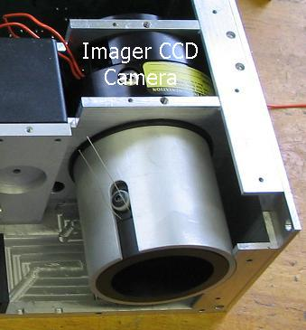
Figure 3.11 Camera in the instrument
  - Viper PC-104 Single-Board Computer

A Viper PC-104 single board computer operates the Imager camera. The Viper runs on an Intel® 400-MHz PXA255 XScale™ RISC processor and includes a comprehensive set of integrated peripherals: DMA controller, real time clock, multiple serial ports, onboard soldered SDRAM and resident Flash, 10/100baseTx Ethernet, USB host and client port, and CompactFlash interface (CF+) [2]. The Viper requires only 1.9 W of power in normal mode and can be made lower by slowing the clock speed of the processor or putting it in stand-by mode when not in use. Figure 3.12 highlights the major components of the Viper.
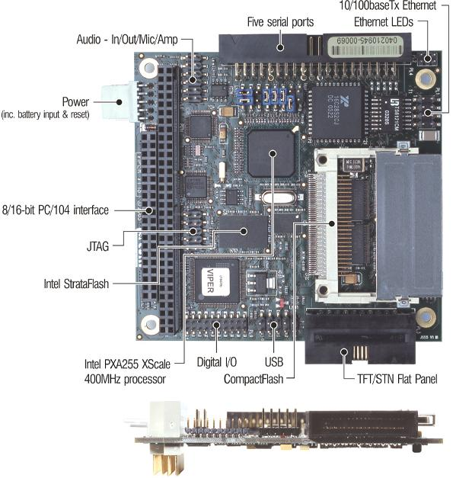
Figure 3.12 Viper single-board computer
    - Specifications

Table 3.2 lists the specifications of the Viper.
    - Software

The operating system employed by the Viper is an embedded version of RedHat Linux based on the 2.4 kernel. It was preloaded and configured in the flash by Arcom, the manufacturer of the board. Applications were precompiled on a desktop computer operating under a full-version of RedHat Linux and uploaded by Ethernet to the Viper.

Table 3.2 Viper specifications
Features | Viper PC-104 Single-Board Computer
Microprocessor | 400-MHz Intel® PXA255 XScale
Flash | 16-MB default, expanded to 1GB CompactFlash
SRAM | 64-MB SDRAM
Network Support | 10/100baseTx Ethernet controller (SMSC 91C111)
Digital Inputs | Eight buffered digital inputs (not used)
Digital Outputs | Eight buffered digital outputs (+5V tolerant) (not used)
Serial Ports | 16550 UART: up to 230.4 Kbits/sec - RS232  16550 UART: up to 230.4 Kbits/sec - RS232  16550 UART: up to 230.4 Kbits/sec - Tx, Rx only via RS232  16550 UART: up to 115 Kbits/sec (128byte Tx/Rx FIFO) - RS232  16550 UART: up to 115 Kbits/sec (128byte Tx/Rx FIFO) - RS422/RS485
USB | Dual USB host ports - v1.1 (Philips ISP1160) and a factory fit USB client option (surface mount link configuration). USB host interface provides support for keyboard and mouse devices.
Real-Time Clock | Yes, accurate to +/- 1 minute/month
BootROM/Firmware | 1-Mbyte ROM - RedBoot for launching embedded Linux
MTBF | 90 000 h (based on MIL-HDBK-217F using generic failure prediction)
Operating System | RedHat Linux
Backup Power | 1.9 W @ + 5 V only supply (typical)
Watchdog Timer | Yes, adjustable timeout from 17 s to 271 s
Operating Temperature | -20 °C to +70 °C (commercial)
Board Size | 91 × 96 mm (PC-104 form factor)

    - Mechanical assembly

The Viper is located in the back corner of the instrument box, next to the photon counter board. It piggybacks the CCD interface board by four Delrin standoffs. The Viper connects to the back panel of the instrument box by small plastic standoffs screwed into the panel by tapered screws. This was done to prevent the board from shorting out on the aluminum surface. Figure 3.7 shows the Viper inside the instrument.

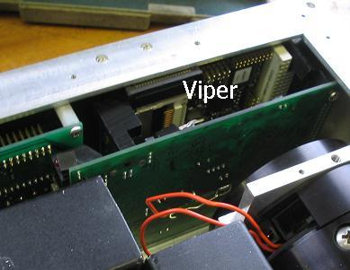
Figure 3.13 Location of Viper inside the instrument box

Several modifications were made to the Viper in order to make it fit the tight dimensions of the box. First, the double row 20-pin right angle serial port connector was desoldered and replaced with a straight angle connector. Second, the LCD display connector (seen next to the 'V' in Viper and butting up against the top bracket in Figure 3.7) was cut in half to allow it to pass under a bracket. Lastly, the back pins of the PC-104 connector were trimmed to decrease the thickness of the board to allow it to sit farther back in the instrument. Trimming both connectors did not pose any problems for the instrument because they were not being used.
  - H8259 Hamamatsu Photometer

All three photometers are Hamamatsu H8279 photometers. The H8259 photometer series are photon counting head devices containing a 28-mm-diameter side-on photomultiplier tube, high-speed photon counting circuit, and high-voltage power supply circuit. A discriminator is included to minimize dark current. An electronic gate circuit (shutter circuit) is also included, but is not used in the instrument. The H8259 is shown in
Figure 3.8.

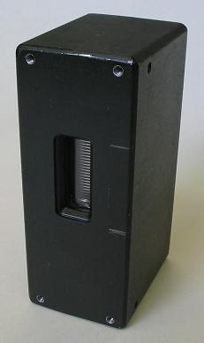
Figure 3.14 Hamamatsu H8279 photometer module

The photometers must operate near or below freezing in order to minimize the amount of dark current in the resulting counts. No cooler of any sort came with the photomultiplier tubes; cooling will be provided by a cold finger that originates from the spacecraft radiator and terminates on, or very near, the photomultiplier tubes. The cold finger has not yet been manufactured, but it will look like a coaxial cable with a center conducting core surrounded by an insulator.

Table 3.3 summarizes the specifications of the H8259 Photometer. The operating temperature for all three photometers will be about -15 °C, about 20 °C below the minimum ambient temperature listed in Table 3.3. Testing will have to be done to verify whether the photometers can still operate at temperatures this low.
    - Count sensitivity and dark current

Figure 3.15 shows the count sensitivity (left) and the dark count (right) of the H8259 and two other photometers from the same family. The count sensitivity of the IBP is about 7.5E4 s⁻¹pW⁻¹ when filtered at 625 nm. The HP and HBP count sensitivity is about
2.1E5 s⁻¹pW⁻¹ for both when filtered between 240 nm and 275 nm, almost three times larger than the IBP.

Table 3.3 Hamamatsu H8279 specifications
Parameter |  |  |  | H8259 | Unit
Input Voltage |  |  |  | +4.5 to +5.5 | V
Maximum Input Voltage |  |  |  | +6 | V
Maximum Input Current |  |  |  | 80 | mA
Effective Area |  |  |  | 4 x 20 | mm
Peak Sensitivity Wavelength |  |  |  | 400 | nm
Dark Count |  |  | Typ. | 30
 |  |  | Max. | 80
Gate | Mode |  |  | Normally ON | -
Gate | Switching Ratio |  |  | 1/1000 | -
Gate | Gate Input | Level |  | C-MOS (High level: +3.5 to +5.0 V) | -
Gate | Gate Input | Input Impedance |  | 1 | kΩ
Gate | Gate Input | Gate Width (FWHM) |  | 50 μs to infinity | -
Gate | Gate Input | Rep. Rate | Max. | 10 | kHz
Pule-pair Resolution |  |  |  | 35 | ns
Output Pulse Width |  |  |  | 30 | ns
Output Pulse Height |  |  | Typ. | 2.2 | V
 |  |  | Min. | 2.0 | V
Recommended Load Resistance |  |  |  | 50 | Ω
Signal Output Logic |  |  |  | Positive logic | -
Operating Ambient Temperature |  |  |  | +5 to +40 | °C
Storage Temperature |  |  |  | -20 to +50 | °C
Mass |  |  |  | 220 | g

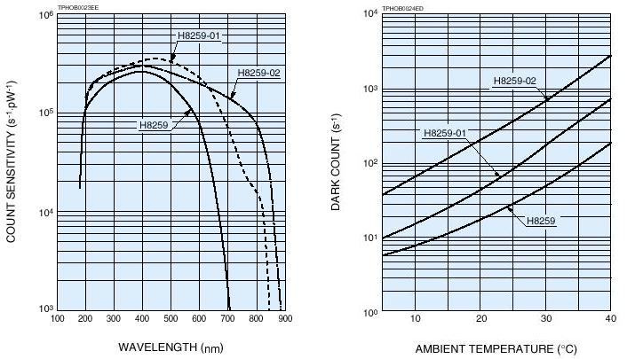
Figure 3.15 Count sensitivity and dark current plots of H8259

The dark current experienced by the photometers was measured in a lab and found to be less than that shown in the right plot of Figure 3.15. Each photometer averaged about
5 counts/s, instead of the 20 counts/s shown in the figure, when operated in pitch dark at room temperature (about 22 °C). No tests were done at different temperatures because the photometers did not have a cooler of any sort attached to the photomultiplier tubes, and it was not convenient to operate them in an oven or refrigerator.
    - Mechanical assembly
      - IBP

Figure 3.16 shows how the IBP mounts inside the instrument box. The top of the IBP is secured to a narrow aluminum wall by two screws. A slot cut into the bottom aluminum panel of the instrument box captivates the bottom of the IBP.
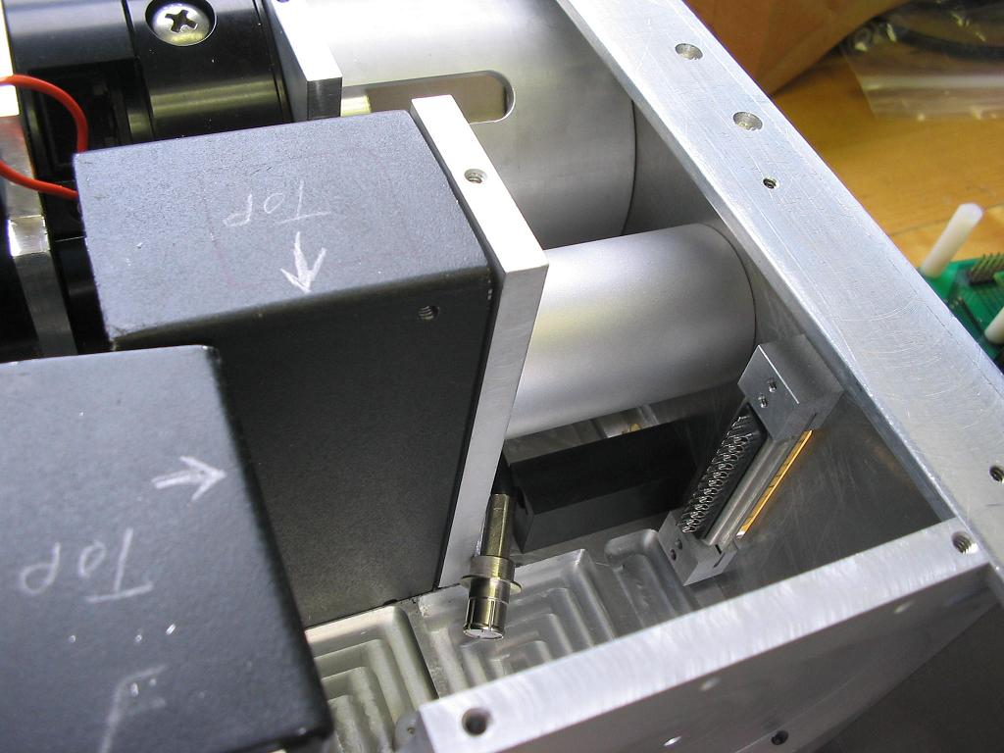
Figure 3.16 IBP inside the instrument
      - HP and HBP

Figure 3.17 shows how the HP and HBP mount inside the instrument box. The HP and HBP attach to an aluminum wall running most of the width of the instrument box. Screws connect the top of the photometers to the wall. Slots cut into the bottom aluminum panel of the instrument box captivate the bottom of each photometer.
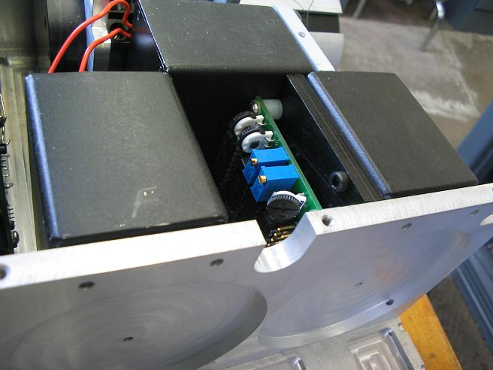
Figure 3.17 HP and HBP inside the instrument
  - Photon Counter Board

The photon counter board interfaces all three photometers. It consists of a custom-designed photometer interface board that counts each pulse coming off of the photometers, a Z-World LP3500 to record the counts, and eight thermistors to sample the temperatures of critical components throughout the instrument. Figure 3.18 shows the top and bottom of the photon counter board (minus the thermistors).
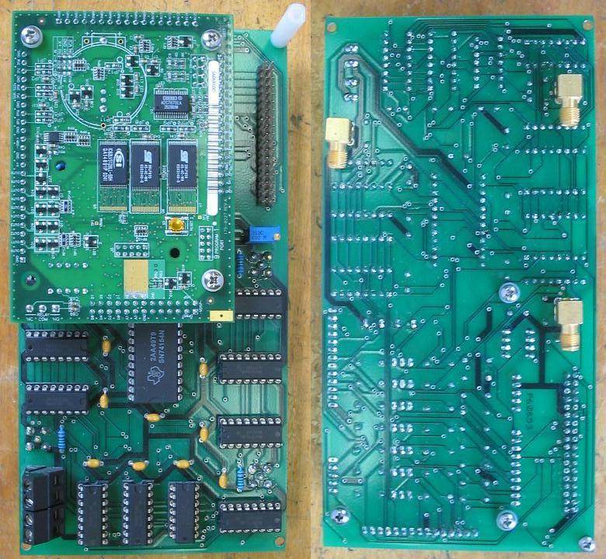
Figure 3.18 Photon counter board
    - Z-World LP3500

The LP3500 (Fox) is a low-power single-board computer manufactured by Z-World. It operates the HP, HBP, and, to a limited extent, the IBP. It controls the counter chips associated with each photometer and reads in, and stores in memory, the count values generated by them at the end of each integration cycle. The main reason for using the LP3500 was that it is small, lightweight, contains a lot of general purpose I/O, and uses very little power. It draws only 20 mA at 5 V when fully operational, and a miniscule
100 µA at 5 V in power-save mode. Figure 3.19 shows what the LP3500 looks like.
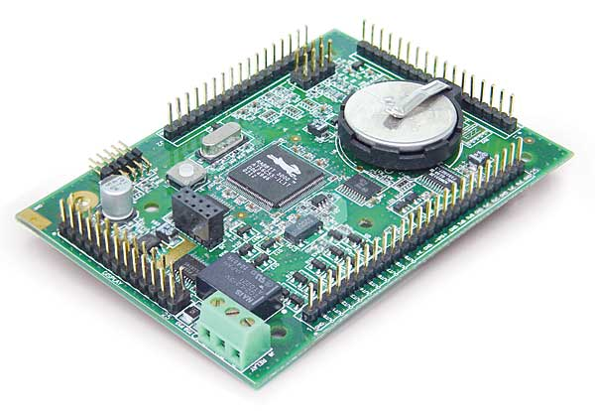
Figure 3.19 Z-World LP3500 Fox

The Rabbit 3000 processor powers the LP3500 [3]. The speed of the processor is only
7.4 MHz; however, this is sufficient because the integration times of the photometers are very slow in comparison to the microcontroller clock speed.

A socketed coin-type battery facilitates long-term data storage of the SRAM and real time clock operation. Files can be stored in RAM and backed up by the battery, even when the external power supply is shut off, avoiding the limited write cycles allowed on the flash.

The LP3500 has 16 digital inputs, IN0-IN15. Eleven of these are used to read the count values off the counter chips. Four digital input pins are used to read the power states of the H(B)P and IBP coming off the shutdown board. The last digital pin is set up as an interruptible pin that connects to the PWM output and times the operation of the counters using an interrupt service routine. The digital inputs are each fully protected between of
0 V and 36 V, and can handle short spikes of ±40 V. The actual switching threshold is approximately 1.40 V. Anything below this value is a logic 0, and anything above is a logic 1.

The LP3500 has 10 digital outputs. The first eight, OUT0-OUT7, can each sink up to 200 mA at 36 V; the last two, OUT8-OUT9, can each source up to 200 mA at 36 V. Five of the sinking outputs control the operation of the counter chips on the photon counter board. Another one controls a relay that supplies power to the counter chips; it turns the chips on whenever either the H(B)P or IBP are in active mode. The last four (two sinking, two sourcing) connect to the shutdown board and control the power states of the H(B)P and IBP.

A bistable relay supplies 12V to the Imager camera. The state of the relay is controlled by software running on the LP3500.

The LP3500 has three, three-wire, RS-232 serial ports, and one half-duplexed RS-485 port; however, only two of the RS-232 ports are used in the instrument. One port attaches to the Taylor interface connector and is used to transmit control and data files. The other attaches to the Viper and is used to transmit IBP count values to the Viper on command, and receive miscellaneous control signals regarding the state of the IBP photometer.

A PWM signal drives an interrupt on pin 0 of the digital inputs. This provides a timing reference when reading the count values off the photometer counter chips. The waveform square wave operates at 3600 Hz with a 50% duty cycle.

Programs were developed using Z-World’s Dynamic C® software development environment. An extensive library of drivers and demo programs was provided to ease the rapid development of applications. Dynamic C® is an integrated C compiler, editor, loader, and debugger designed specifically for Rabbit microprocessor-based products. See Appendix A for more information on the pin layout of the LP3500.
      - Specifications

Table 3.4 lists the major specifications of the LP3500.
      - Mechanical assembly

The LP3500 plugs directly into the photometer interface board and is secured to it by three plastic standoffs. This is depicted in Figure 3.20.
Table 3.4 Z-World LP3500 specifications
Feature | Z-World LP3500
Microprocessor | Low-EMI Rabbit 3000™ at up to 7.4 MHz
Flash | 512 K (2 x 256 K), 100 000 write cycle
SRAM | 512 K
Backup Battery | Socketed 3 V lithium coin-type, 265 mA·h, supports RTC and SRAM
Digital Inputs | 16 protected to ±36 V DC
Digital Outputs | 10 total: 8 sink and 2 source 200 mA each, 36 V DC max.
Relay | 1 SPDT, 1 A, 30 V DC, bi-stable
Analog Inputs | Eight 11-bit single-ended or four 12-bit differential, 1 MΩ input impedance, up to 200 samples/sec.  Multiple software-controlled programmable gain voltage ranges from 0–1 V to 0–20 V)  4 channels can be set individually for 4–20 mA with plug-in jumpers  1 channel has software-selectable power voltage-monitoring option
Analog Outputs | 3 unfiltered PWM, 1 kΩ output impedance
Serial Ports | 1 RS-485 3 RS-232 (three 3-wire OR one 5-wire and one 3-wire)  1 logic-level serial interface for optional add-ons  1 3 V CMOS-compatible (programming)
Serial Rate | Max. asynchronous baud rate = CLK/8
Real-Time Clock | Yes
Timers | Ten 8-bit timers (6 cascadable from the first) and one 10-bit timer with 2 match registers
Main Power | 3–30 V DC, 20 mA max. @ 7.4 MHz, 100 µA max. @ 2 kHz
Backup Power | Used to reduce current in power-save mode, 2.7–3.3 V @ 100 µA max
Operating Temperature | –40 to +70 °C
Board Size | 93 mm × 66 mm × 11 mm

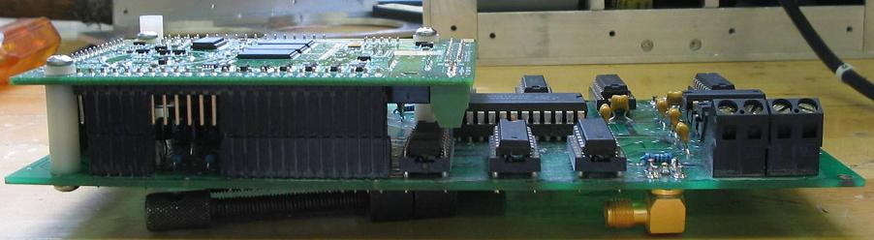
Figure 3.20 Z-World attached to photon counter board
    - Photometer interface board

It is a multipurpose board whose primary purpose is to count pulses coming off the photometers and relay them to the LP3500. The counts associated with the HP and HBP are read in every second and stored on the LP3500; counts associated with the IBP are read in on command from the Viper and are communicated back to it at a later time.

The photometer interface board also reads the temperatures of eight thermistors scattered throughout the instrument. The thermistors are located near temperature-sensitive components where performance can be significantly affected by temperature. The temperatures are given in terms of voltages and are read in by eight A/D inputs on the LP3500.

The photometer interface board is shown in Figure 3.21.
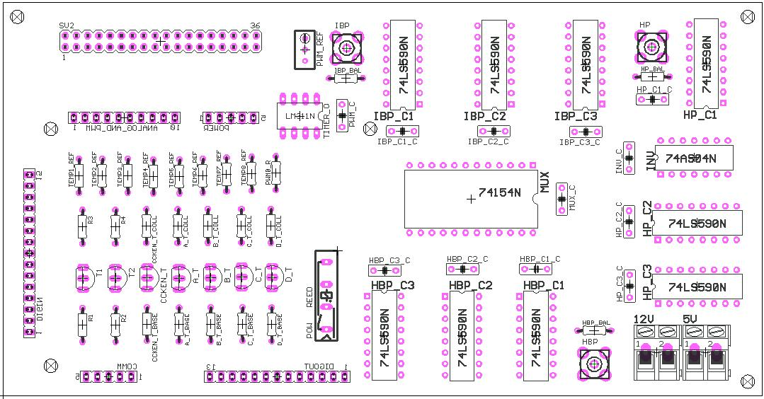
Figure 3.21 Photometer interface board
      - Schematics

The photon counter board consists of six major subsystems: counters, counter selector, LP3500 interface to counter selector, PWM driver, and power control. The following section illustrates each subsystem and explains their functionality.

Counters

Each photometer interfaces to a 25-bit counter on the photometer interface board. The counters keep track of the number of photons striking the photomultiplier tubes in a given integration period. The schematic of one of the counters (HBP) is shown in Figure 3.22.
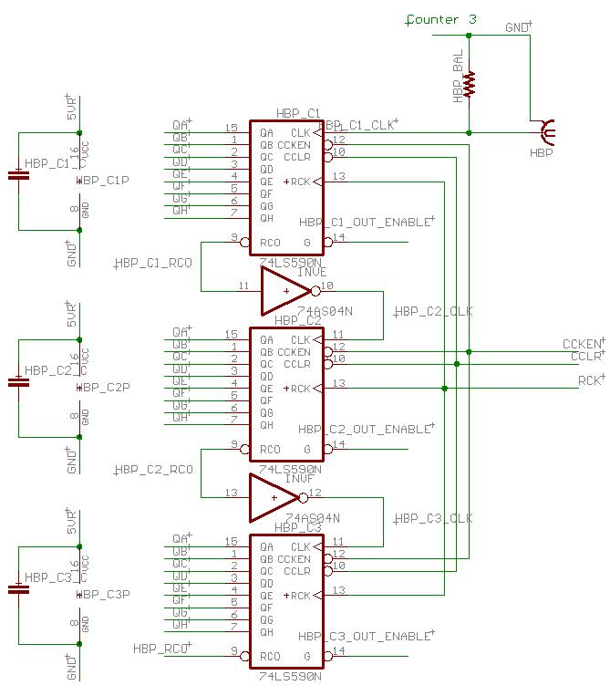
Figure 3.22 Generic counter schematic

The counter schematic for the HP, and for the most part the IBP, are exactly the same as Figure 3.22, except change any reference of HBP to HP and IBP, respectively. The discussion pertaining to the operation of the counters in general will be given with respect to the HBP counters, and any differences that might exist between it and the others will be mentioned where appropriate.

Each counter is made up of three 74LS59 8-bit counter chips connected in series with a carryout bit coming off the third counter. This translates to a total word size of
33 554 431 before count rollover. Each 8-bit counter has two parts: an accumulator to count photometer events and a storage register for preserving the counts. The storage register has parallel outputs. Separate clocks are provided for both the binary counter and storage register. The binary counter features a CCLR pin for clearing count values and a CCKEN pin for enabling the counter clock. Both of these signals drive the outputs of the selector subcircuit, except for the IBP, where the CCLR comes directly from the LP3500 and the CCKEN comes from the camera shutter signal. Both the counter and register clocks are positive-edge triggered. Because of the way they are built, the counter state would always be one count ahead of the register if the counters were directly tied together. This problem was solved by adding the inverters between the ripple-carry out of one counter and the clock of the other counter.

The HBP signal comes onto the photon counter board through a SMA female connector that terminates at a parallel connection of the CLK input of the first counter and a 750-Ω resistor. The 750-Ω resistor divides down the input impedance seen by the photometer to around 450 Ω, instead of about 2-100 kΩ (depending on the state of the counters) if it terminated directly at the CLK input. This balances the load better with the photometer output because the output impedance of the photometer is only 50 Ω. This minimizes reflections of signals coming off the photometers and reduces the chance that a reflection might be taken as another photon event.

Each photometer waveform triggers the clock signal on the first counter and increments the count value of the chip. A change in state occurs on the ripple carry out (RCO) pin every time the count value rolls over, triggering the clock signal and incrementing the count value on the second counter. Likewise, count rollovers on the second counter increment the count value on the third counter. Any rollover on the third counter terminates on one of the input lines to the LP3500.

The eight outputs of the counters are labeled QA through QH. Identical outputs of every counter, even those belonging to the other photometer chips, are tied together to form an eight bit bus. The LP3500 selects which output to place on the bus by sending the appropriate signal to a selector chip, which in turn places a LOW on pin 14 of the desired counter chip.

A 0.1-μF capacitor connects across the power and ground pin of each chip on the photometer interface board. This helps avoid potential changes in state of any chip if neighboring chips were to change state and cause momentary spikes or dips in the power supply.

Counter selector

The 74154 selector chip shown in Figure 3.23 controls all nine counter chips. The 74154 translates a four bit word on the A, B, C, and D inputs to a LOW on one of its 16 outputs. A selector output state is HIGH if an output is not selected. The possible states of the selector chip are given in Table 3.5.
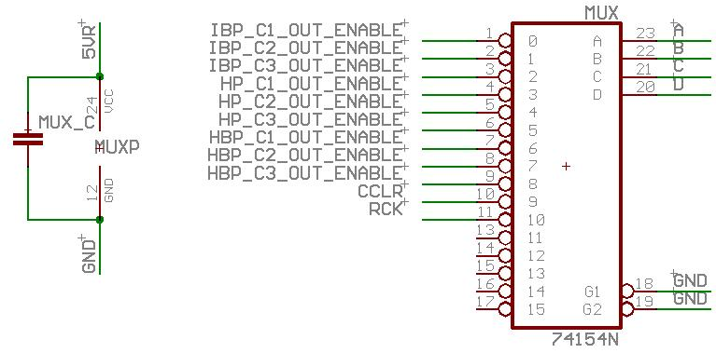
Figure 3.23 Photon counter board counter selector schematic
Table 3.5 Photometer interface board counter selector states
Selector Operation | Selector Signal (ZD|ZC|ZB|ZA)
IBP counter least significant byte | 0x0
IBP counter middle significant byte | 0x1
IBP counter most significant byte | 0x2
HP counter least significant byte | 0x3
HP counter middle significant byte | 0x4
HP counter most significant byte | 0x5
HBP counter least significant byte | 0x6
HBP counter middle significant byte | 0x7
HBP counter most significant byte | 0x8
Counter clock clear | 0x9
Register clock | 0xA
Default (no operation) | 0xB

The first nine selector outputs connect to pin 14 of each counter chip. When any of the selector output lines goes LOW, it activates the tristate buffers on the outputs of the selected counter and places the count value of it on the 8-bit data bus, where it can then be read by the LP3500. Output 9 is used to clear the count values of the HP and HBP; a separate line clears the count values of the IBP from the LP3500. Output 10 clocks the outputs of the internal counters of the HP and HBP counter chips onto the internal register; this function of the IBP counters is handled by a signal from the camera via the shutdown board. The reason for this separation is that the IBP counters are treated as part of a separate instrument and are operated asynchronously from the HP and HBP counters.

Z-World interface to counter selector

Eight of the LP3500 outputs are sinking, meaning they draw current into the pins instead of out, and cannot interface directly with the chips on the photon counter board. Instead, they interface through the transistor ladder network shown in Figure 3.24. The transistor ladder network interfaces the LP3500 to the inputs of the selector. All resistors in the network are 10 kΩ. When an output of the LP3500 goes HIGH, it turns off the transistor, pulling the collector of the transistor and the input to the selector HIGH. Conversely, when an output of the LP3500 goes LOW, it turns on the transistor, pulling the collector of the transistor and the input to the selector LOW.

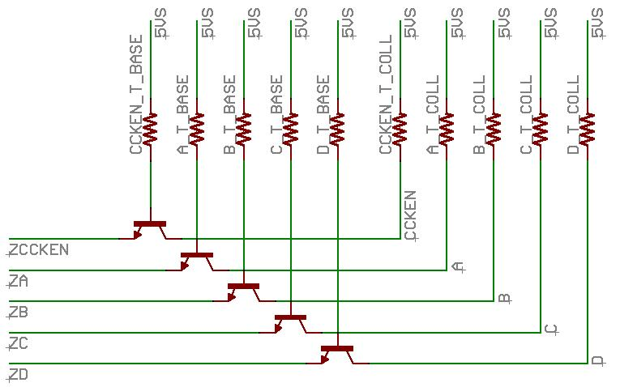
Figure 3.24 Photon counter board Z-World interface schematic

PWM driver

The clocks of the counter chips are synchronized by a PWM signal driving an interrupt on one of the digital inputs (synchronization for the IBP counters come from the camera via the shutdown board). This signal can not go directly from the PWM output to the digital input because of grounding issues. Instead, it routes through the interface circuit of Figure 3.25.

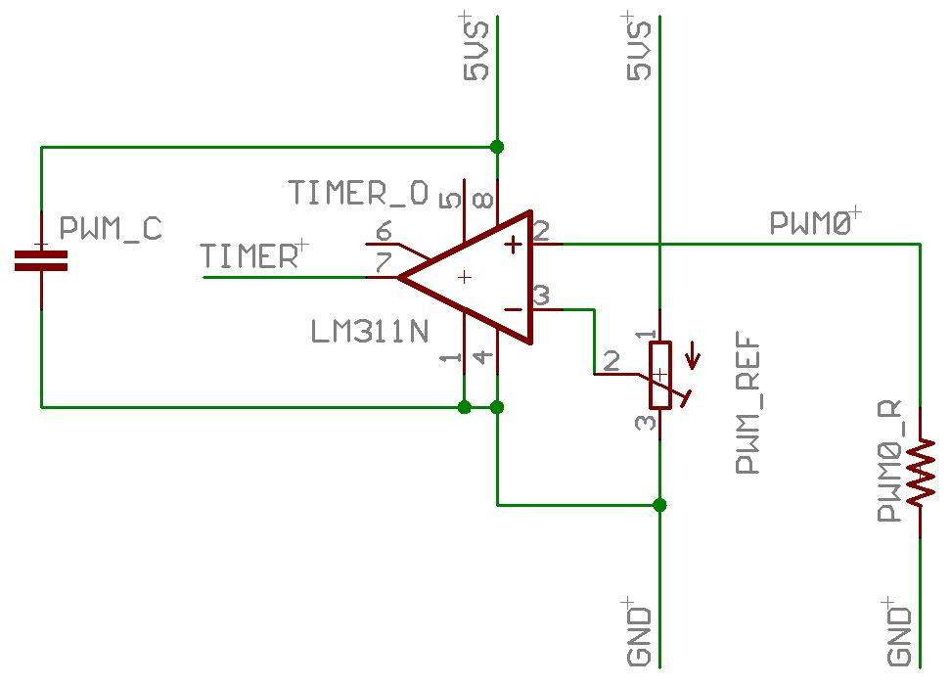
Figure 3.25 Photon counter board PWM driver schematic

The PWM interface circuit compares the PWM signal to a known reference supplied by a pot and a 5-V power supply. When the PWM voltage goes above this reference, the output is HIGH; when it goes below the reference, the output is LOW. The timer interrupt is triggered by a rising clock edge.

Power control

Taylor provides a 5-V and 12-V power supply to the photometer interface board. They come onto the board through two, two pin, screw terminals. The 5-V supply is used by most of the ICS and the LP3500; the 12-V supply is used by the thermistors and the camera attached to the LP3500 relay. The 5-V supply to the photon counter chips comes from a relay located on the board. The relay is turned ON whenever either the HBP, HP or the IBP is in the active region, and OFF when they are all in the inactive region. The power control circuitry is shown in Figure 3.26.
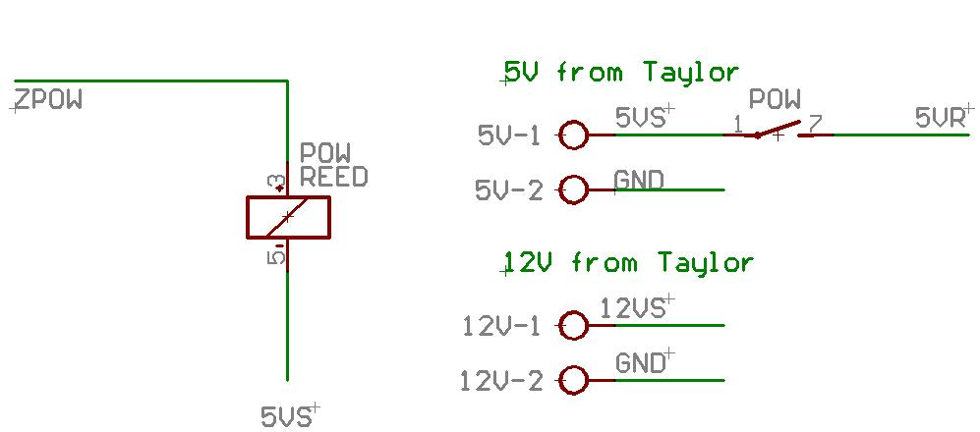
Figure 3.26 Photon counter board power control schematic

The relay is directly controlled by the LP3500 and is normally ON,. When the output of the pin goes HIGH, the relay turns off; when the pin goes LOW the relay turns ON. (All pin references in this section are detailed more extensively in Appendix A).
      - Mechanical assembly

Each photometer connects to an SMA connector located on the back of the board. They connect to the back because there is not enough room to allow passage of the connectors on the front side when the board is secured to the instrument box. Figure 3.27 shows the connectors on the board. The board lies along the back panel of the instrument box next to the large 3-in lens/filter tube of the HBP. It is secured on one side by a notch cut into a slab of Delrin. It is secured on the other side by a plastic standoff that screws both into the back panel of the instrument box and one corner of the board. Figure 3.28 shows how the board mounts inside the instrument.
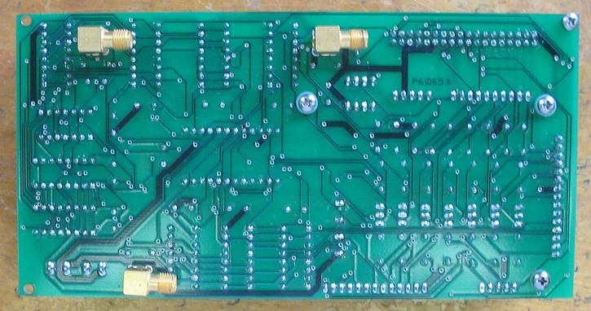
Figure 3.27 Back of photometer interface board

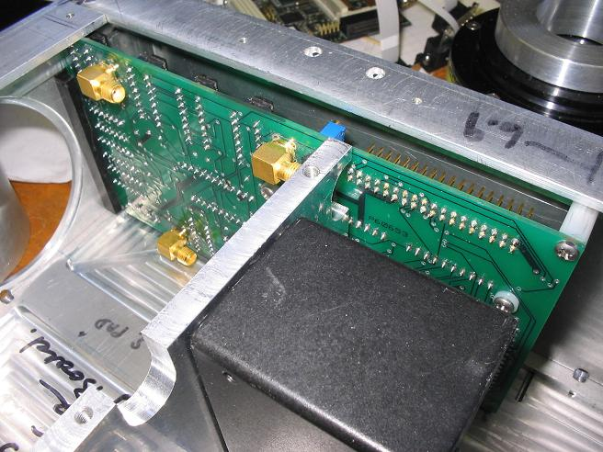
Figure 3.28 Location of photon counter board inside the instrument box
    - Temperature sensors (thermistors)

Temperature information is provided by eight Vishay thermistors scattered throughout the instrument near temperature-sensitive components. The following components have a

thermistor placed nearby to measure their temperature:
- Imager filter
- Camera CCD array
- IBP filter
- HP, HBP, and IBP photomultiplier tubes

The reason for measuring the Imager and IBP filter temperatures is because temperature can affect the location their peak sensitivity. This can be a problem because they are narrowband and any slight shift in the center wavelength can misalign the filter sensitivity with respect to the airglow spectra of interest, preventing their instruments from seeing the spectra effectively.

The reason for measuring the temperature of the photomultiplier tubes and camera CCD array is that the temperature can significantly affect the amount of noise present in them. Scientists on the ground need to know how much noise is present in them in order to be able to ascertain the quality of the measurements.

Thermistors are temperature-sensitive resistors. The relationship between resistance and temperature is governed by the Steinhart and Hart equation:
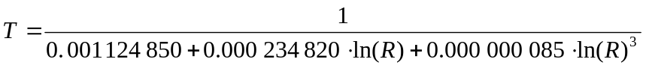 (3.1)

The variable T is the temperature measured by the thermistor in Kelvins and R is the resistance of the thermistor in ohms. The basic temperature-sensing circuit employed on the photometer interface board is shown in Figure 3.29. The thermistor is labeled as Rth. Temperature is given in terms of a voltage, Vout, and is sensed by one of the A/D inputs on the LP3500. The voltage Vout at different thermistor temperatures is depicted in Figure 3.30.

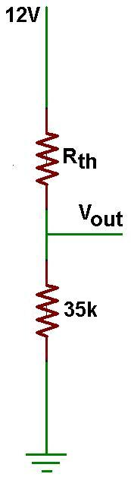
Figure 3.29 Basic temperature sensing circuit
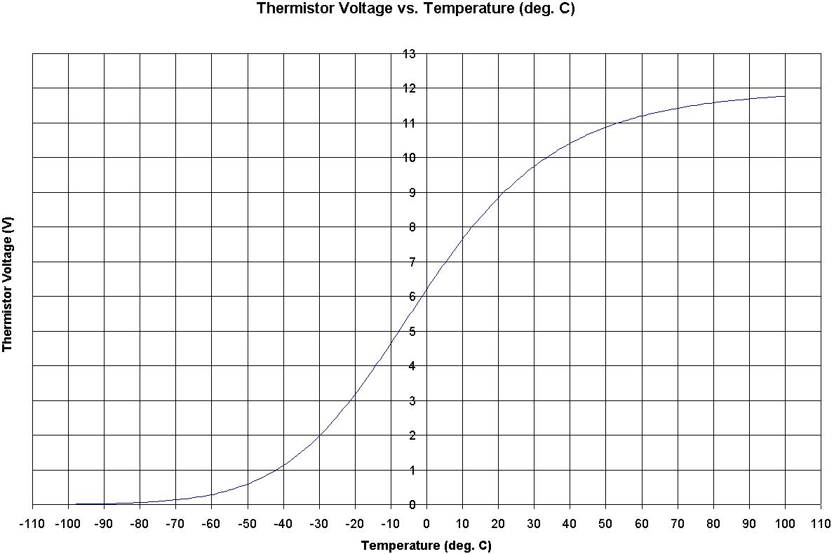
Figure 3.30 Thermistor voltage vs. temperature
  - Shutdown Board

The second custom board built for the instrument serves a dual purpose: it provides protection against excessive light striking the photometers and interfaces the CCD camera shutter signal to the IBP counters on the photon counter board. The shutdown board is shown in Figure 3.31.
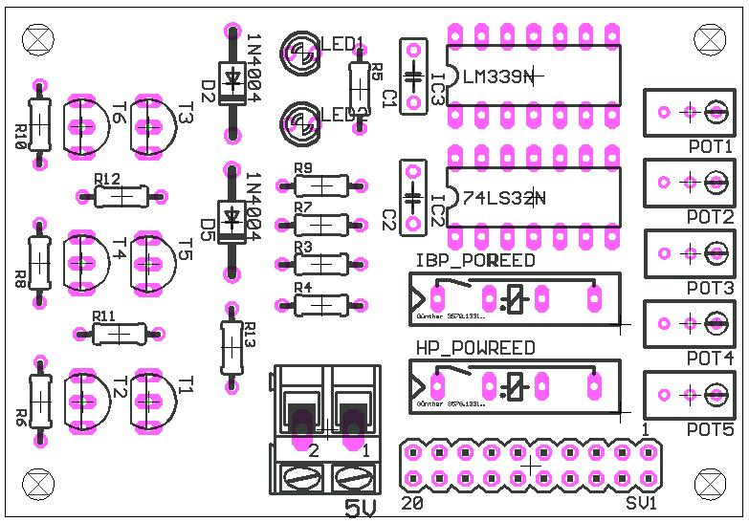
Figure 3.31 Photometer shutdown board

The shutdown board consists of two major parts: a circuit board and photodiode sun sensors.
    - Circuit board
      - Schematic

The photon counter board consists of two major subsystems: an H(B)P and IBP shutdown circuit, and a camera shutter control interface. Both of these systems are depicted and explained in the following section.

Shutdown circuit

Figure 3.32 shows the shutdown circuitry for the HP and HBP. The shutdown circuitry for the IBP is identical, except replace any reference of HP or HBP with IBP. Photodiodes are current-producing devices. Light striking the photodiode generates a current that, when flowing through the first pot on the far right, produces a voltage that is sensed by the positive terminal of a comparator. This voltage is compared with a reference voltage produced by a second pot connected to the negative terminal of the same comparator. If the photodiode voltage is larger than the reference voltage, indicating excessive light striking the photometer, the output of the comparator is HIGH; otherwise, it is LOW, indicating normal light level. This state, called H(B)P_OPAMP_OUT, can be sensed by the LP3500 on the photon counter. If this state is HIGH, or if the LP3500 pulls H(B)P_ENABLE HIGH, the output of the OR gate on the right is HIGH, causing the OR gate on the left to latch, turning off the relay supplying power to the photometer.
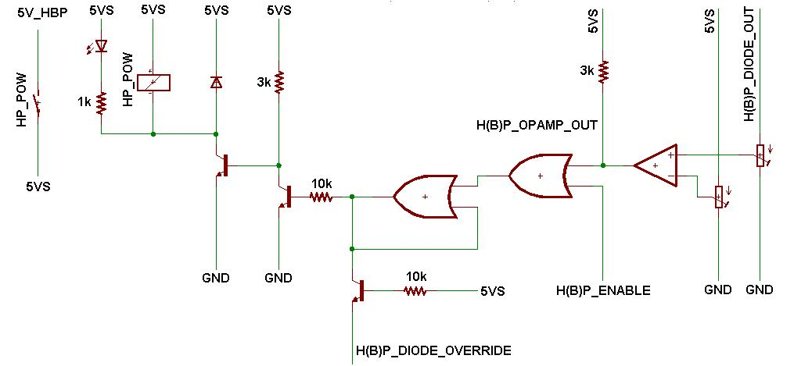
Figure 3.32 Shutdown circuit schematic

When H(B)P_DIODE_OVERRIDE goes LOW, it pulls the OR gate on the left LOW, turning on the relay supplying power to the photometer. This condition persists as long as H(B)P_DIODE_OVERRIDE is LOW, regardless of the state of the photodiode or H(B)P_ENABLE.

The states of the shutdown circuitry for HP, HBP, and IBP are given in Tables 3.5 and 3.6, respectively.

Table 3.6 Power states of HP and HBP
H(B)P_DIODE_OVERRIDE | H(B)P_ENABLE | HP & HBP Power State
LOW | LOW | ON
LOW | HIGH | ON
HIGH | LOW | Photodiode controlled
HIGH | HIGH | OFF

Table 3.7 Power states of IBP
IBP_DIODE_OVERRIDE | IBP_ENABLE | IBP Power State
LOW | LOW | ON
LOW | HIGH | ON
HIGH | LOW | Photodiode controlled
HIGH | HIGH | OFF

Camera shutter control interface

In addition to controlling the power states of the three photometers, the shutdown board also interfaces the shutter signal coming off the Imager camera to the photon counter board. The signal can not directly connect to the photon counter board due to grounding issues.

The signal driving the shutter of the camera is used to control the counter chips on the photometer interface board associated with the IBP. The signal activates the counters only when the shutter of the camera is open.

The shutter signal connects to the negative terminal of the shutter motor inside the CCD camera housing. The positive terminal of the motor is connected to +12 V. Generally speaking, to open the shutter, the signal is pulled LOW, causing a +12 V drop across the motor, turning it on and opening the shutter vane. Conversely, to close the shutter, the signal is pulsed HIGH, causing a net zero drop across the motor, turning it off and closing the shutter vane.

When activated, the shutter signal does not look like a perfect square wave; instead, it looks something like Figure 3.33. The signal initially drops to about 4 V, then increases to about 7 V, then drops finally all the way to near ground. It stays near ground until the shutter is deactivated. This stairstep pattern is probably caused by the load of the shutter changing during the movement of it.
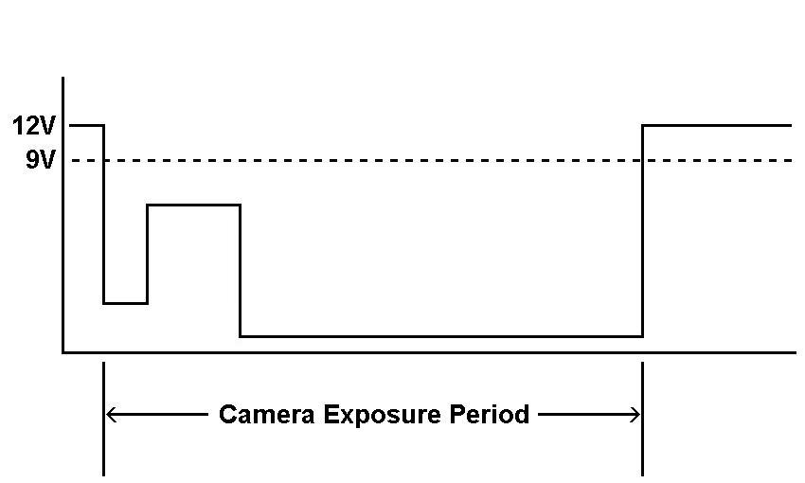
Figure 3.33 CCD camera shutter signal

A schematic of the camera interface is shown in Figure 3.28. The pot of the camera interface circuit sets a reference near 9 V; if the shutter signal drops below this voltage, it will consider the shutter open and pull VIPER_CLK_EXT LOW; otherwise, it will consider the shutter closed and pull VIPER_CLK_EXT HIGH. This is a good assumption to make since the signal had been investigated and found to never go above 9 V whenever the shutter is activated.
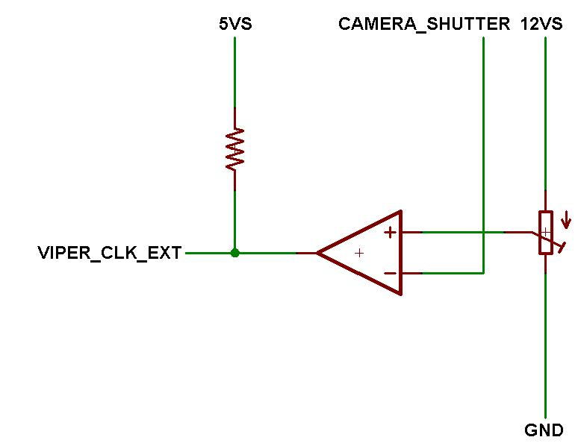
Figure 3.34 CCD camera interface schematic
      - Mechanical assembly

The shutdown board is located in an unusual place. It attaches by four standoffs to a slab of Delrin that is secured to the HP by a single screw in the corner. Figure 3.35 shows how the shutdown board attaches to the HP. The screw securing the Delrin to the photometer can be seen next to the plastic standoff on the far right.
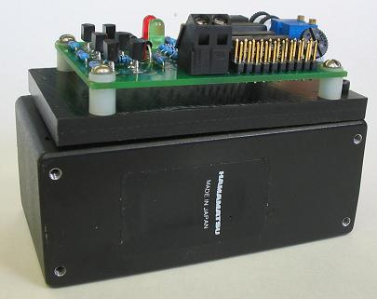
Figure 3.35 Photometer shutdown board attached to HP

The shutdown board is held upright inside a crevice by the photometer. A screw inside the crevice captivates the bottom of the Delrin slab. Figure 3.36 illustrates the location of the shutdown board inside the instrument.
Figure 3.36 Photometer shutdown board inside the instrument

The shutter's signal exits the camera by wire through the side of the camera near the power and signal headers. Figure 3.37 shows this wire exiting the camera, along with another one attached to the 12-V supply of the positive terminal of the shutter motor.
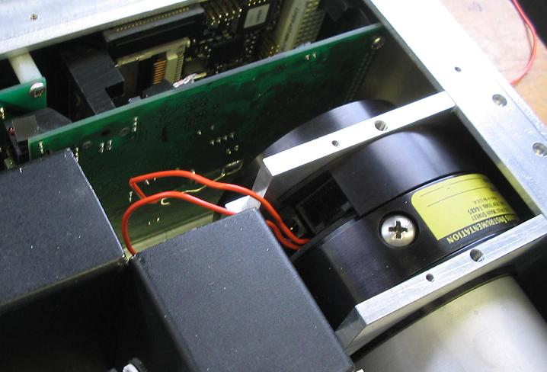
Figure 3.37 Camera shutter signal connections
    - Sun sensors

Two photodiodes sense the ambient light in the region of the three photometers. Both are high-speed Everlight PIN photodiodes in a standard 5-mm-diameter package. One photodiode is associated with the HP and HBP and the other is associated with the IBP. Figure 3.38 shows what one looks like.
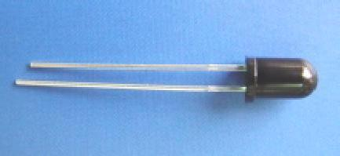
Figure 3.38 Everlight photodiode

These photodiodes have a peak sensitivity in the infrared, yet the HP and HBP operate in the ultraviolet, and the IBP operates in the visible. The assumption when using this type of photodiode is that the ambient light from the sun will be spread relatively evenly across these different wavelengths, so that the amount of light striking the photodiode in the infrared will be about the same as that in the visible and ultraviolet.

Figure 3.39 depicts the basic photodiode sun sensor circuit employed by the shutdown board. Photodiodes are current-producing devices. Light striking the photodiode generates a current that flows into the resistor labeled R. This results in the voltage Vout that is sensed by the shutdown board comparator. R is a pot set to a few megaohms because the current produced by the photodiode is very small.
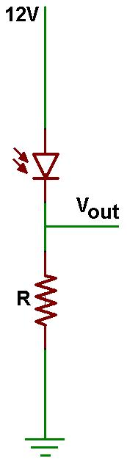
Figure 3.39 Basic photodiode sun sensing circuit
      - Specifications

Figure 3.40 lists the major specifications of the photodiodes. Looking at the upper right plot, the sensitivity of the photodiode peaks around 900 nm, about 600 nm larger than the sensitivity of the HP and HBP, and about 250 nm larger than the IBP. As mentioned previously, light from the sun spreads relatively evenly around these wavelengths, and the intensity of the light at 900 nm will be about the same as that at the smaller wavelengths.

Looking at the bottom left plot, the dark current generated in the photodiodes increases logarithmically with temperature. Dark current flows in the opposite direction of the normal current, causing the power dissipation in the photodiode to go down with increasing temperature (the currents are canceling each other out). This will lower the voltage Vout of Figure 3.39 because there is less current flowing through the resistor R. This means that, given the same amount of incident light, the photodiode will register less light at one temperature than at a lower temperature; the shutdown board might shut the photometers down in one situation and not in the other. To get around this problem, the pots that set the reference level are set sufficiently high enough to accommodate higher temperatures. This means that the photometers will be shut off prematurely in the low temperature side, but they will nevertheless be protected, if not overprotected.
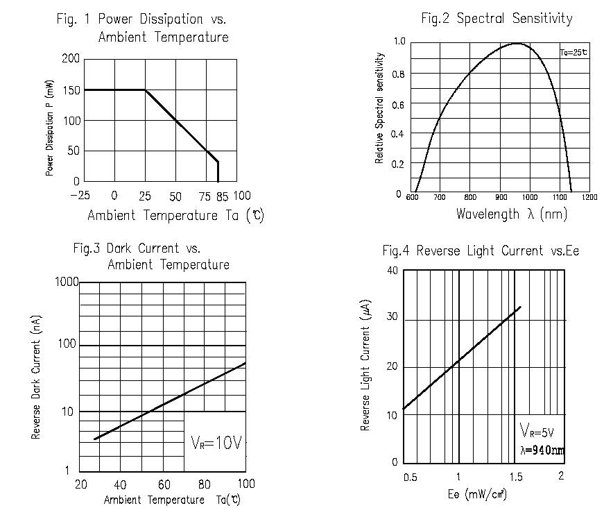
Figure 3.40 Everlight photodiode specification plots
      - Mechanical assembly

Both photodiodes are built into Delrin lens tube assemblies. Delrin was chosen because it has some give to it and will not overly stress the lenses. Figure 3.35 shows a cross-sectional view of the lens tube. The photodiode slips through a hole in the back of the Delrin block and is captivated in place by a plastic screw whose head overlaps the back part of the photodiode. Shrink-wrap is placed over the leads exiting the back to prevent them from shorting out. Figure 3.42 shows this detail.
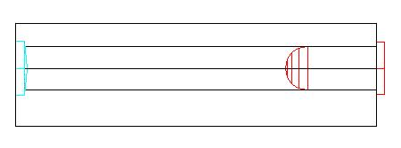
Figure 3.41 Schematic of photodiode assembly

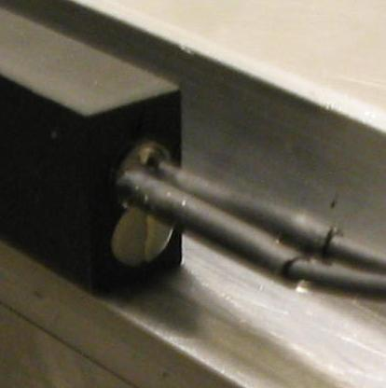
Figure 3.42 Back detail of photodiode tube assembly showing photodiode

The lens fits in a notch cut into the front of the block and is captivated in place by the Delrin structure on the back and the instrument panel wall on the front. The round part of the lens faces towards the inside of the instrument box. Grooves are cut around the lens to allow easy removal it. Figure 3.43 shows this detail.
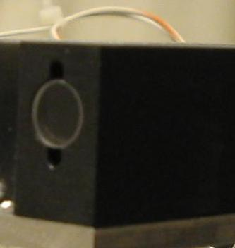
Figure 3.43 Front detail of photodiode tube assembly showing lens

Each sun sensor lens accommodates a field of view slightly larger than the field of view of the photometer system they are designed to protect. This was done as a precautionary measure in order to allow the photodiodes to see any excessive light in advance of the photometers. Table 3.8 lists the mechanical specifications of the two lenses.
Table 3.8 Mechanical specifications of sun sensors
 | IBP Sun Sensor | H(B)P Sun Sensor
Lens Diameter | 6mm | 6mm
Lens Focal Length | 30mm | 72mm
Lens Material | BK7 | BK7
Lens Type | Planoconvex | Planoconvex
FOV | 12.08° | 5.05°

HP and HBP sun sensor

The H(B)P sun sensor is located near the Hertzberg photometer lens/filter tube in the corner of the instrument. An access hole was cut into the corner of the wall that supports this tube to allow access of the photodiode wire leads. Figure 3.44 shows the location of the sensor inside the instrument and Figure 3.45 shows the sensor looking from outside the instrument box.
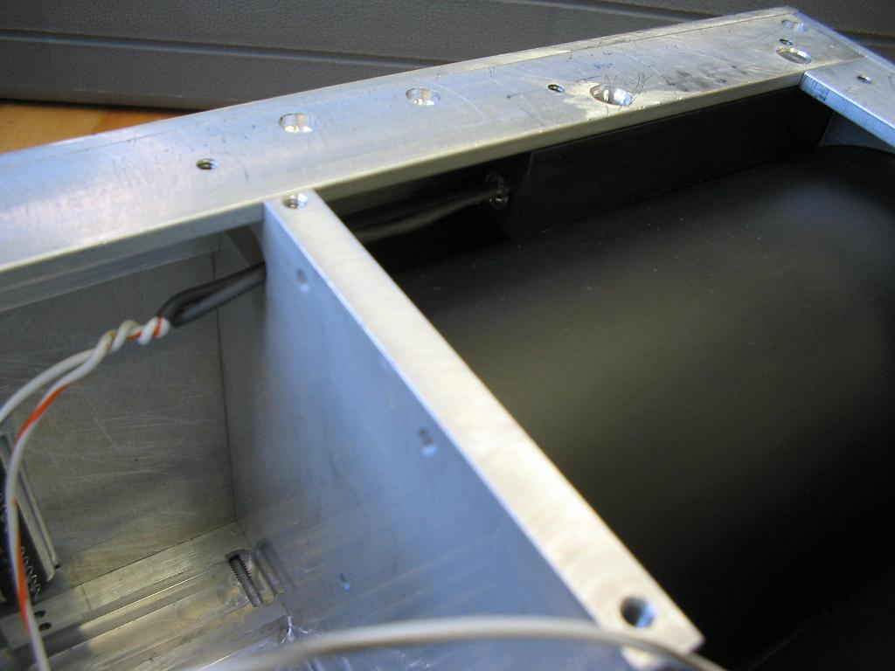
Figure 3.44 Location of HP and HBP sun sensor inside the instrument
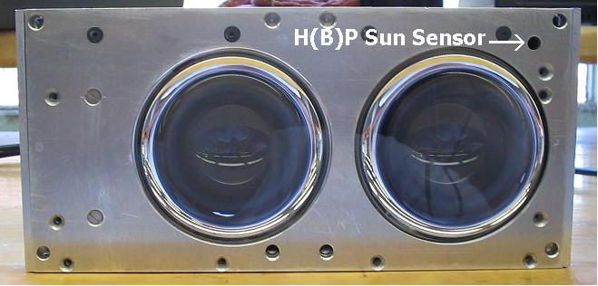
Figure 3.45 Location of HP and HBP sun sensor looking from the outside

IBP sun sensor

The IBP sun sensor is located below the IBP lens/filter tube next to the Taylor interface connector. Figure 3.46 shows the location of the sensor inside the instrument, and
Figure 3.47 shows the sensor looking from the front of the instrument box.
Figure 3.46 Location of IBP sun sensor inside the instrument

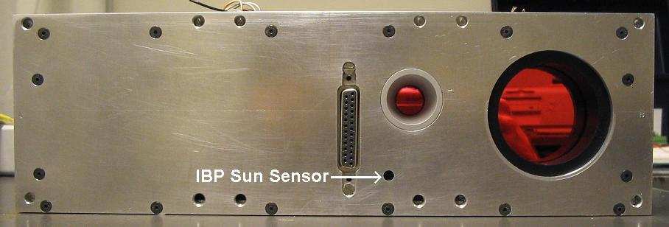
Figure 3.47 Location of IBP sun sensor looking from the outside
  - Imager, IBP, HP, and HBP Lens and Filter Assemblies

There are six imaging systems in the instrument. All six utilize lenses to focus light onto the imaging instrument. However, only the Imager, IBP, HP, and HBP use filters to selectively filter the incoming light; the sun sensors look at a broad range of incoming light. These instruments are interested in measuring phenomena that exist at certain spectra, so light entering these instruments has to be selectively filtered.

Figure 3.48 shows what the basic lens and filter assembly looks like. Table 3.9 summarizes the lens and filter tube assemblies of the Imager, IBP, HP, and HBP.
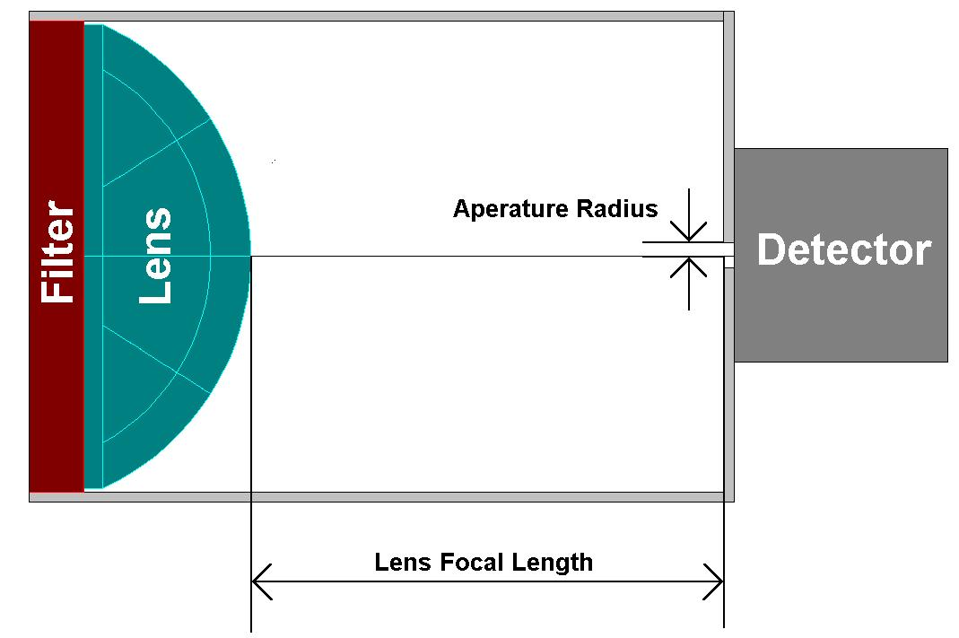

Figure 3.48 Basic lens and filter mechanical assembly present in all optics

Table 3.9 Mechanical specifications of Imager, IBP, HP, and HBP lens and filter tube assemblies
 | Imager | IBP | HP | HBP
Lens Diameter | 50 mm | 25.4 mm | 75 mm | 75 mm
Lens Focal Length | 50 mm | 54.4 mm | 90 mm | 90 mm
Lens Material | BK7 | BK7 | Fused Silica | Fused Silica
Lens Type | Planoconvex | Planoconvex | Planoconvex | Planoconvex
Aperture Radius | - | 3.5 mm | 3 mm | 3 mm
FOV | 16.48 ° | 7.88 ° | 1.91 ° | 1.91 °
Filter Center Transmission Wavelength | 630.45 nm | 625.2 nm | 275 nm  (has not arrived yet) | 240 nm  (has not arrived yet)
Peak Transmission | ~82% | ~82% | ~82%  (has not arrived yet) | ~82%  (has not arrived yet)
FWHM | 3.1 nm | 3.0 nm | 30 nm  (has not arrived yet) | 30 nm  (has not arrived yet)
Filter Temperature Measurement? | Yes | Yes | No | No

    - Lenses

All lenses used in the instrument are planoconvex. These lenses are spherical on one side and flat on the other. The flat sides of all lenses face away from the instrument and is where the filters are located. This configuration was chosen because it helps maintain a consistent transmission bandwidth for light coming into the lens/filter tube. If the filter was located on the opposite side of the lens (the round side), light passing through the filter would come in at an angle at the periphery of the filter and would experience a different transmission bandwidth than light coming through the center where it enters head-on.

All lenses measure their focal points with respect to an imaginary focal plane located near the lens. This plane can be located inside or even outside the lens. The focal plane of a planoconvex lens is located in two different spots, depending on which way the light enters the lens. In all of the imaging instruments, light enters the lens on the flat side. In this configuration, the imaging plane is located at the vertex of the sphere on the round side of the lens (see Figure 3.49).
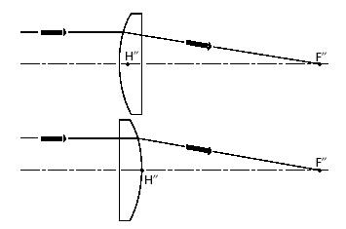
Figure 3.49 Location of focusing planes in planoconvex lens

Having the flat side on the outside versus the inside made it somewhat difficult to machine the filter and lens tube assemblies for HP and HBP. This is because the location of the focal plane on the inside forces the focal length of the lens to be closer to the inside of the instrument in comparison to what would be the case if the lenses were biconvex, or if the planoconvex lens was flipped around, and the imaging plane was closer to the center of the lens. Space for the lens and filter tubes was extremely limited, and the HP and HBP lenses are over an inch thick, so this forced the photometers to be compacted together in order to make space.

The field of view (FOV) of the lenses is determined by the focal length of the lens and the aperture.

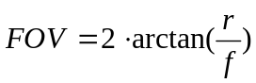 (3.2)

The variable r is the radius of the aperture and f'is the focal length of the lens. It is desirable to have the focal point of the lens inside the aperture. However, because of space constraints, the focal points of the HP and HBP lenses are approximately 1 mm outside the apertures, on the photometer side of the holes.

Lenses used for imaging visible wavelengths are made of BK-7. These lenses include those used by the Imager, IBP, and all three sun sensors. BK-7 is a lightweight plastic material with a high transmittance at these wavelengths. BK-7 is not suitable for the HP and HBP because they are imaging in the ultraviolet region; BK-7 would be nearly opaque at these wavelengths. Instead, these lenses are made from fused-silica, which has a reasonably high transmittance in the ultraviolet region. The transmission profile of BK-7 and fused-silica are shown in Figures 3.44 and 3.45, respectively.

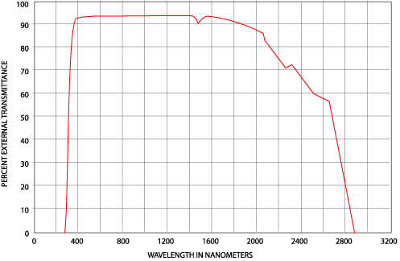
Figure 3.50 Transmittance of BK-7 at different wavelengths
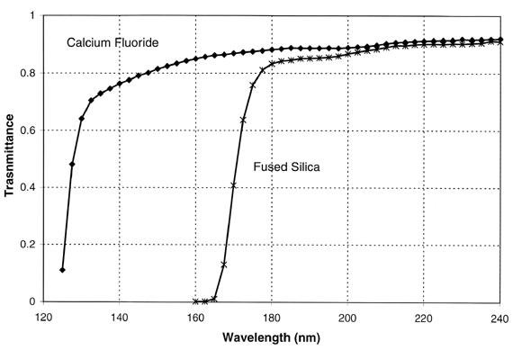
Figure 3.51 Transmittance of fused-silica and calcium flouride at different wavelengths
    - Filters
      - Imager

The Imager filter required a center wavelength sensitivity (CWL) of 630 nm and a full-width, half-max, bandwidth (FWHM) of 3 nm. Looking at Figure 3.52, the actual filter manufactured by Barr Associates has a CWL of 630.45 nm and a FWHM of 3.1 nm. These differences are acceptable to our application. The diameter of the filter is 2 in, slightly larger than the 50-mm (1.969-in) diameter of the Imager lens.
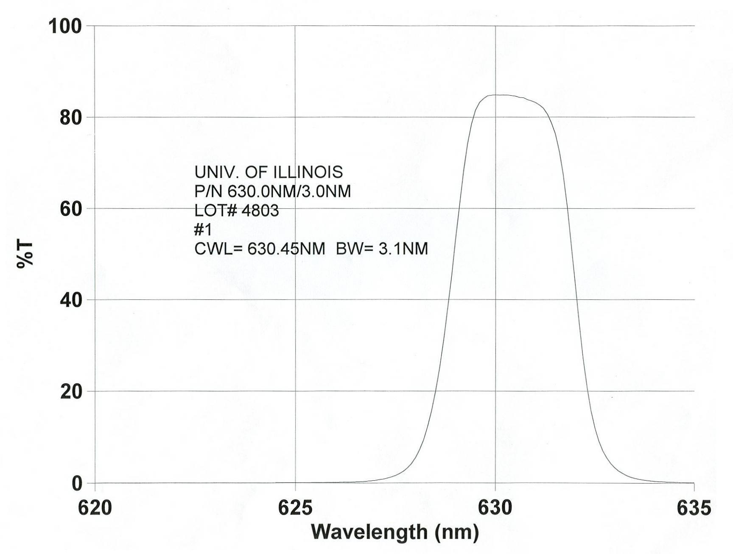
Figure 3.52 Filter transmission specifications of Imager filter
      - IBP

The IBP filter required a CWL of 625 nm and a FWHM of 3 nm. This filter is designed to measure the off-channel background illumination present in the Imager. Looking at Figure 3.53, the actual filter manufactured by Barr Associates has a CWL of 625.2 nm and a FWHM of 3.0 nm. These differences are acceptable to our application. The diameter of the filter is 16 mm, quite a bit smaller than the 1-in IBP lens diameter. This was a mistake on the part of Barr; we initially were quoted for a 16-mm filter but revised our workorder to 1 in, the same as the IBP lens, before they actually started building the filter. Barr accepted our change but did not follow through with it. Instead, they built our filter to our original specification.
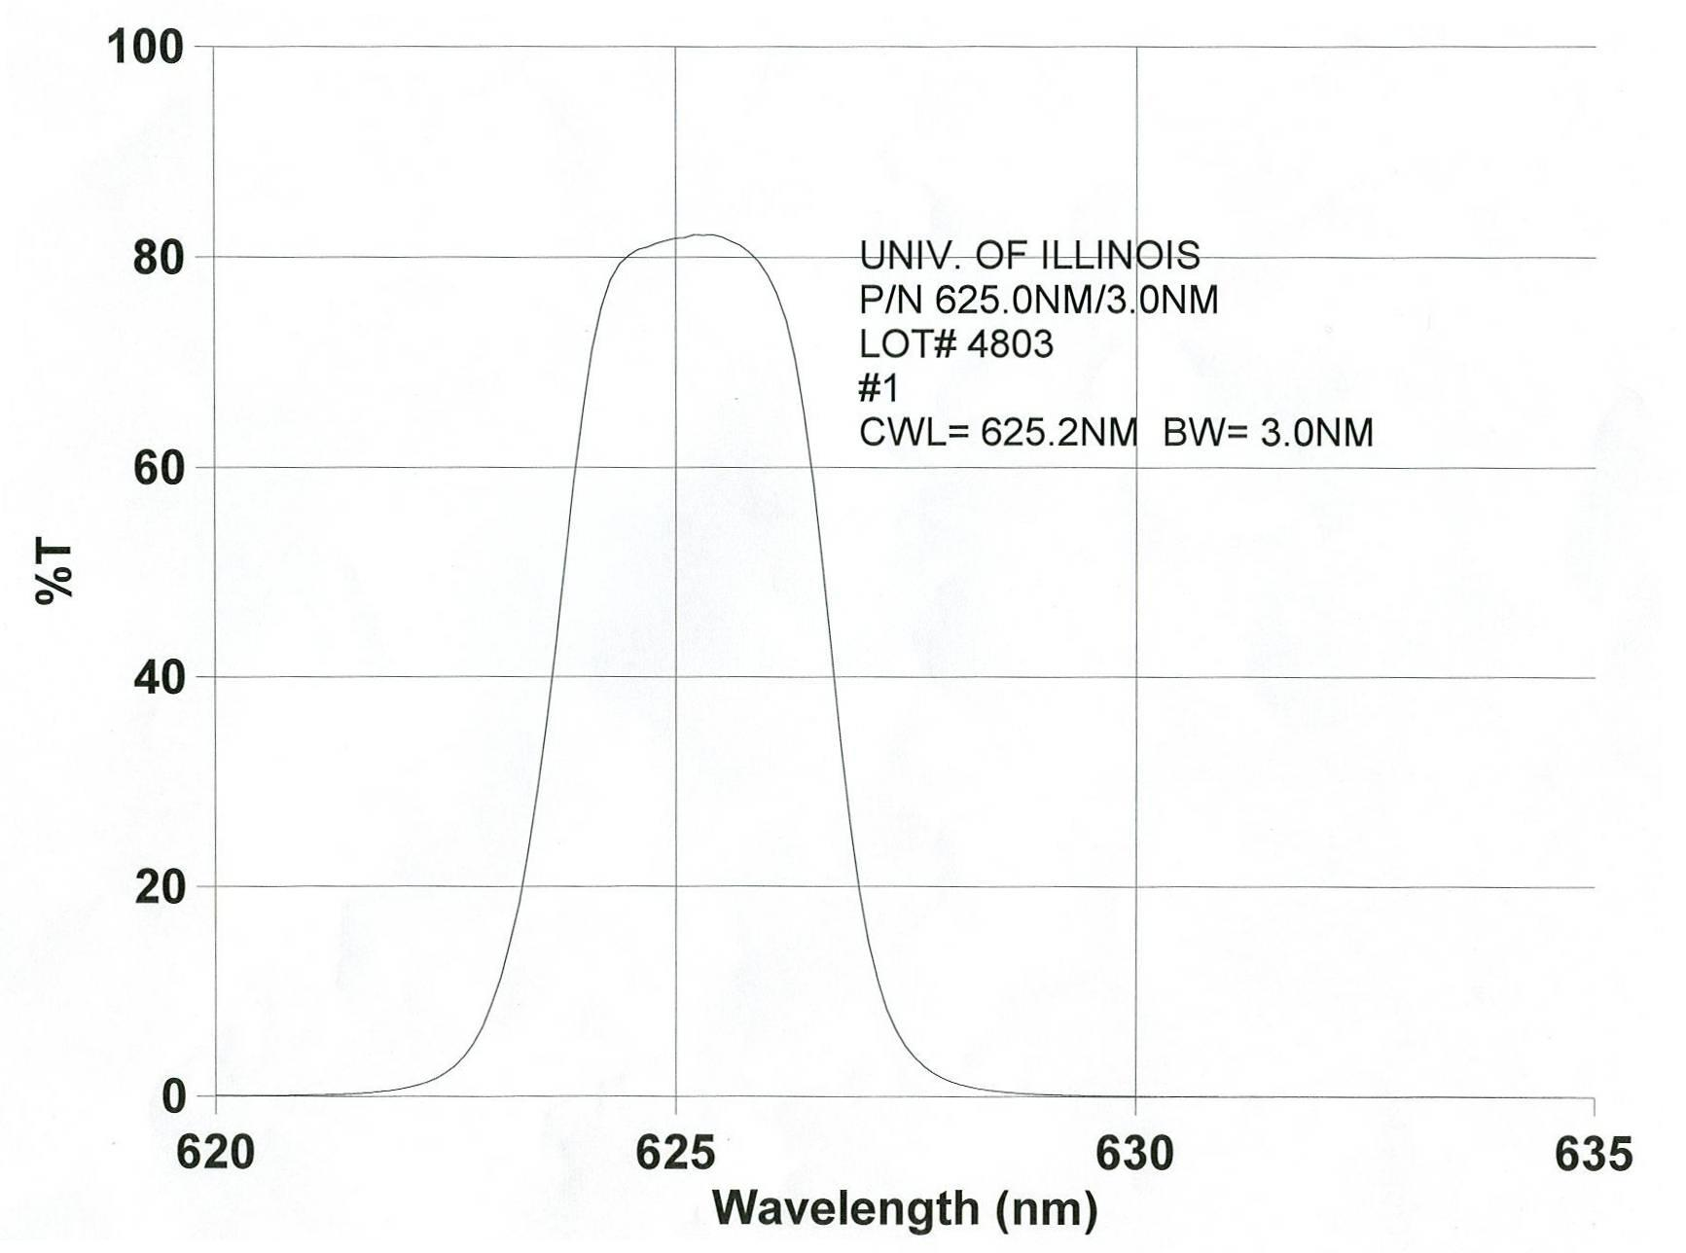
Figure 3.53 Filter transmission specifications of IBP filter
      - HP

The filter for the HP was ordered in August of 2003 and had not arrived as of July of 2004.
      - HBP

The filter for the HBP was ordered in August of 2003 and had not arrived as of July of 2004.
    - Mechanical assemblies

Delrin was used for any structure making direct contact with the lenses and filters because it has some give to it, and would absorb any pressures placed upon them by the surrounding instrument box.
      - Imager

Figure 3.54 shows the Imager lens and filter tube assembly. A Delrin assembly that slides inside an outer aluminum tube captivates the Imager lens and filter. It is held in place inside the aluminum tube by two Delrin rings on either side of the assembly. The outer aluminum tube slides onto an aluminum ring threaded into the front flange of the camera and is captivated by the front of the camera and the front panel of the instrument box.
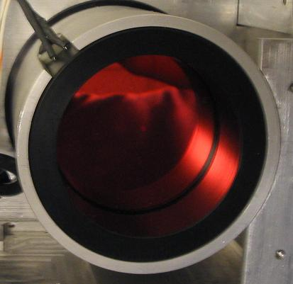
Figure 3.54 Imager lens and filter tube assembly

A thermistor passes through the aluminum tube and inner Delrin assembly and touches the rim of the filter ring. It relays the temperature of the filter to the photon counter board. Shrink-wrap was applied to the leads of the thermistor to prevent them from shorting out.
      - IBP

Figure 3.55 shows the IBP lens and filter tube assembly. A Delrin tube that slides inside an outer aluminum tube captivates the IBP lens and filter. The outer aluminum tube is captivated on one end by a hole cut into a narrow aluminum wall and on the other end by the front of the instrument box.
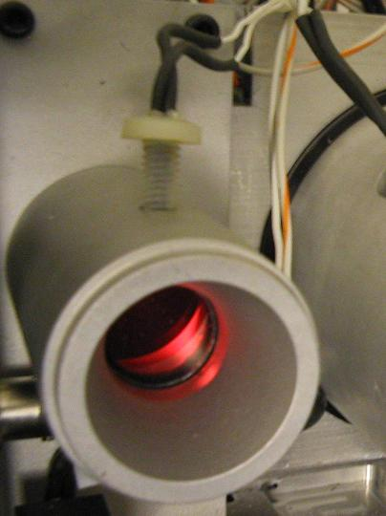
Figure 3.55 IBP lens and filter tube assembly

A thermistor passes through a plastic screw in the outer aluminum tube and inner Delrin tube and touches the rim of the filter ring. It relays the temperature of the filter to the photon counter board. Shrink-wrap was applied to the leads of the thermistor to prevent them from shorting out when they pass through the screw body.
      - HP and HBP

Figure 3.56 shows the HP and HBP lens and filter tube assembly. The lens and filter tube assemblies for both the HP and HBP are identical. Each consists of a milled Delrin tube notched on one end to accept the lens and filter. A spacer fits inside the notch and is placed on the outside of the lens to separate it from the filter. The tubes are captivated inside the instrument box by a hole cut into an internal wall that the photometers mount to and the side panel of the instrument box. Figure 3.57 shows this arrangement.
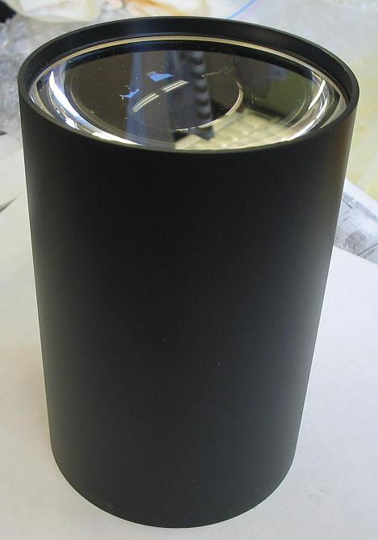
Figure 3.56 HP and HBP lens and filter tube assembly
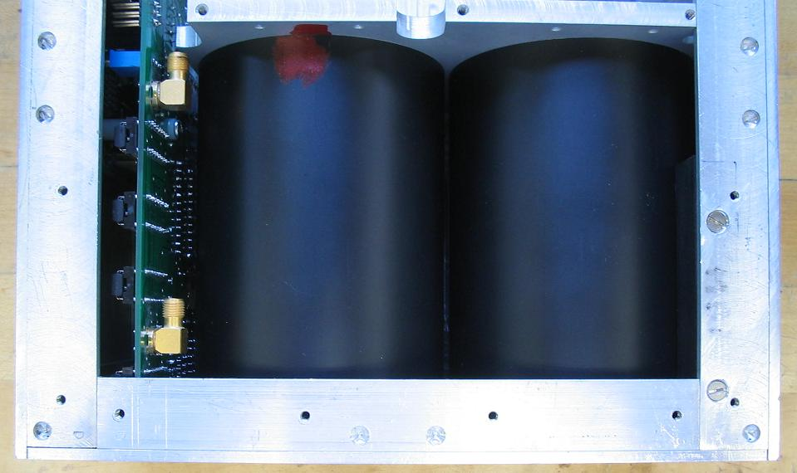
Figure 3.57 HP and HBP lens and filter tubes captivated in the instrument box
  - Taylor Interface Connector

The electrical interface to the Taylor computer occurs at the female 25-pin Sub-D connector that is located at the front of the instrument, near the IBP and the Imager lens/filter tube access holes. All power and signal lines going between the instrument and the rest of the spacecraft go through this connector.
    - Pin specifications

The pin layout of the Taylor interface connector is shown in Table 3.10. There are numerous 5-V connections made to the connector. This was done to allow anyone testing the components inside the instrument to selectively power only those components they wish to test.
Table 3.10 Taylor interface connector pin specifications
Pin | Connection | Function
1 | 5V | Photon Counter Board Power
2 | GND | Photon Counter Board Power
3 | 12V | Camera and Thermistor Power
4 | RX | Viper Serial Port 4
5 | TX | Viper Serial Port 4
6 | GND | Viper Serial Port 4
7 | RX | Z-World Serial Port E
8 | TX | Z-World Serial Port E
9 | GND | Z-World Serial Port E
10 | GND | Camera and Thermistor Ground
11 | 5V | Shutdown Board Power
12 | GND | Shutdown Board Power
14 | TX+ | Viper Ethernet
15 | TX- | Viper Ethernet
16 | GND | Viper Ethernet
17 | RX+ | Viper Ethernet
18 | RX- | Viper Ethernet
19 | 5V | Viper Power
20 | GND | Viper Power

    - Mechanical assembly

The connector slides through a slip in two anchor blocks placed on the top and bottom of the connector. Two screws thread through the front to hold the connector in place within the slips. Two additional screws thread through the male Taylor connector and the female instrument connector to secure the two together. Figure 3.58 shows the connector held in place by the anchor blocks. All wires are soldered to the connector. Shrink-wrap was applied to the leads to prevent any of them from shorting each other out.

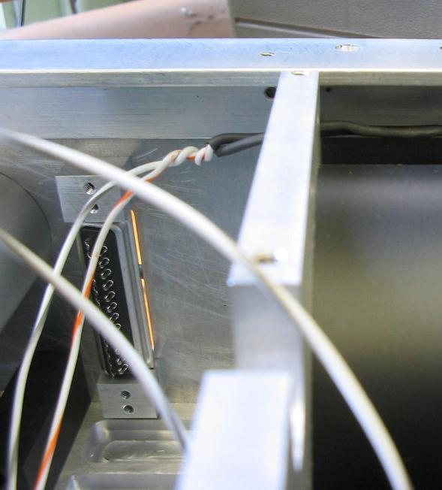
Figure 3.58 View of bare interface connector looking from inside the instrument box

Operation
  - Signal-to-Noise Ratio

All detectors in the instrument collect not only light from celestial objects, but also unwanted signals, called noise. Noise comes in two forms: dark current and readout noise. Dark current comes from thermal agitation of electrons within the detectors and is time and temperature dependent. Readout noise, on the other hand, has a constant mean and is generally associated with the amplifier circuitry that processes the signals coming off the detectors.

The operation of the instruments will be governed in large part by the amount of noise expected under different scenarios. If the noise present in a detector is large enough, it can swamp out legitimate signals and make any data collected by the instrument meaningless. The goal is then to determine in what manner the instruments can be operated in order to increase the incident signal strength with respect to any noise generated in the detectors in order to guarantee good measurements. The method for doing this is through the signal to noise ratio (SNR).
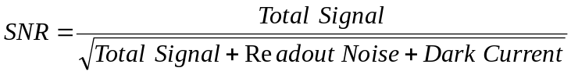 (4.1)

The objective is to maximize the SNR. There are two general methods for accomplishing this: increase the exposure period and, in the case of the Imager camera, bin pixels. However, this reduces the resolution of the exposures, and limits the amount of information that can be extracted from them. Consequently, the SNR can not be made arbitrarily large; there must be a balance between signal strength and resolution.

The desired SNR values for the instrument are given in Table 4.11. Note the smaller SNR for the Imager than the photometer imaging systems. It turns out that it is more difficult to obtain a large SNR for the CCD camera than it is for the photometers. This is because the SNR depends on the feature size of the imaging area, and the pixel size of the CCD camera is considerably smaller than the size of the exposure area on the photomultiplier tubes. This is the reason why the SNR requirement of the camera is less than that of the photometers.
Table 4.11 Instrument SNR specifications
 | CCD Camera | IBP | HP | HBP
Minimum SNR | 50 | 100 | 100 | 100

    - Imager

Determination of the Imager SNR is broken up into two steps: calculating the signal strength and calculating the level of noise present. These calculations are made at different exposure times and temperatures and plugged into Equation (4.1) to provide the SNR for these different conditions. The SNR values are then plotted with respect to exposure time, temperature, and binning, and a determination on how best to operate the instrument can be made by noting when the Imager operates at an SNR of 50 or above.

Signal calculation

The total signal received by the CCD camera is
(4.2)

The first term in the equation is the intensity of the incoming light in Rayleighs. It is calculated by integrating the product of the quantum effeciency of the filter, the signal intensity, and the camera CCD quantum efficiency, across the range of wavelengths passing through the imaging system. Since the Imager and IBP filter are narrowband (the FWHM of each is 3 nm), and the light will be assumed to spread evenly across the bandwidth of the filter, the integral can be simplified by replacing it with the product of a constant light intensity, the peak transmissivity of the filter, and the peak quantum efficiency of the camera CCD. This simplification treats the filter and CCD quantum efficiencies as having a bandwidth that is infinitesimally narrow centered at the peak transmissivity. The light intensity used in the equation will be 200 Rayleighs, the minimum intensity expected (a dark night sky has a light intensity of roughly 250 Rayleighs). This value is used because if the low end with a weaker signal can satisfy the SNR requirement, a greater light intensity signal would also be able to meet the desired SNR value.

The second term in the expression converts the signal in Rayleighs to that of photons per second per area. One Rayleigh represents the light intensity of one million photons of light emitted in all directions per square centimeter of receiver per second, or, in SI units, 7.958 x 10⁸ per square meter per steradian.

The light gathering power (LGP) of the lens system depends only on the pixel dimension of the camera CCD array and the diameter of the lens.
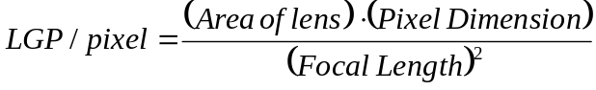 (4.3)

The Imager lens is an f/1 lens, meaning that the diameter of the lens and the focal length are equal. This configuration maximizes the light gathering power of the lens, and consequently the SNR of the system.

Noise calculation

As mentioned previously, noise is present in the exposures in the form of readout noise and dark current. The amount of readout noise was determined by taking a very short dark exposure at the coldest temperature feasible and looking at the statistics of the resulting image. The dark current accretion rate was ascertained by taking a 5-min dark exposure at various temperatures and looking at the statistics of the resulting images. The area contains both dark current and readout noise. The readout noise was subtracted from this value to provide the average dark current present after five minutes. Dark current is linearly dependent on exposure time, so the rate at which dark current accrues each second was calculated by dividing the total dark current gathered in the exposure period by 300, the number of seconds in five minutes. Table C.1 in Appendix C summarizes the signal and noise properties of the Imager.

SNR plots

Figures 4.1-4. show the Imager SNR values at different temperatures, exposure periods, and binning. Looking at the four figures, it is obvious that the camera can not achieve an SNR of 50 with less than 3 x 3 binning. It can be reached after approximately 14 s at
3 x 3 binning and 8 s with 4 x 4 binning. Note that the traces of each plot spread out more as binning is decreased.

The actual exposure time required to achieve an SNR of 50 will probably be less than what was previously calculated. This is because the filter bandwidth has some finite width allowing more light to the camera from other wavelengths, and the minimum light intensity will probably be larger than the 200 Rayleighs assumed in the calculations.
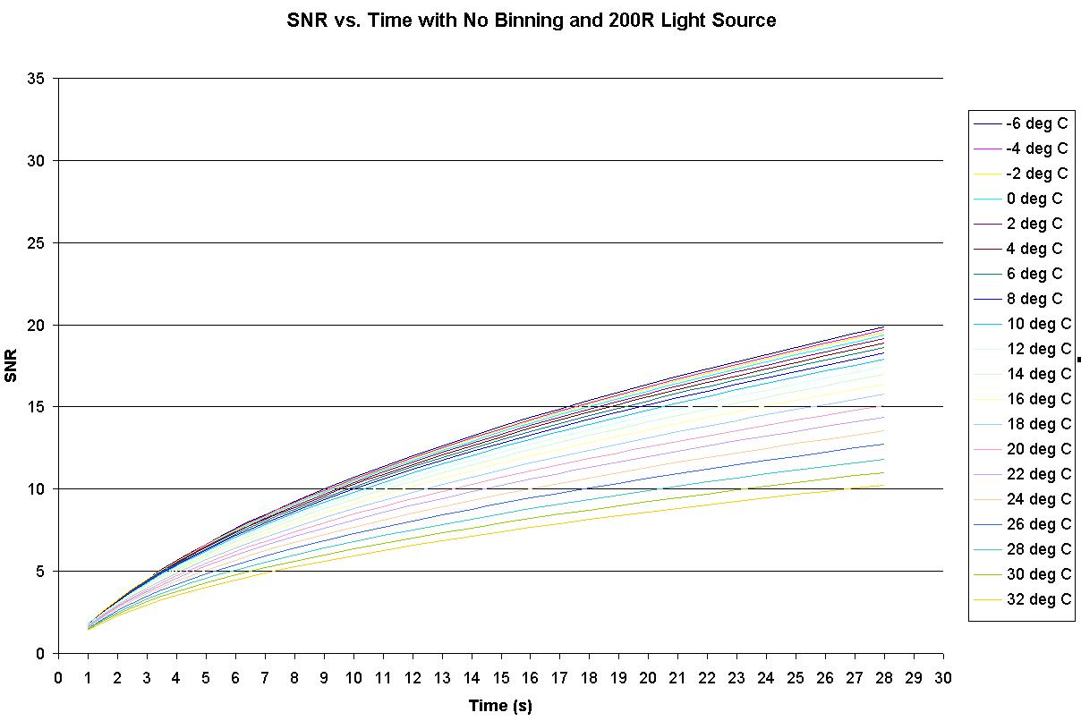
Figure 4.59 Imager SNR vs. time with no binning and 200-R light source

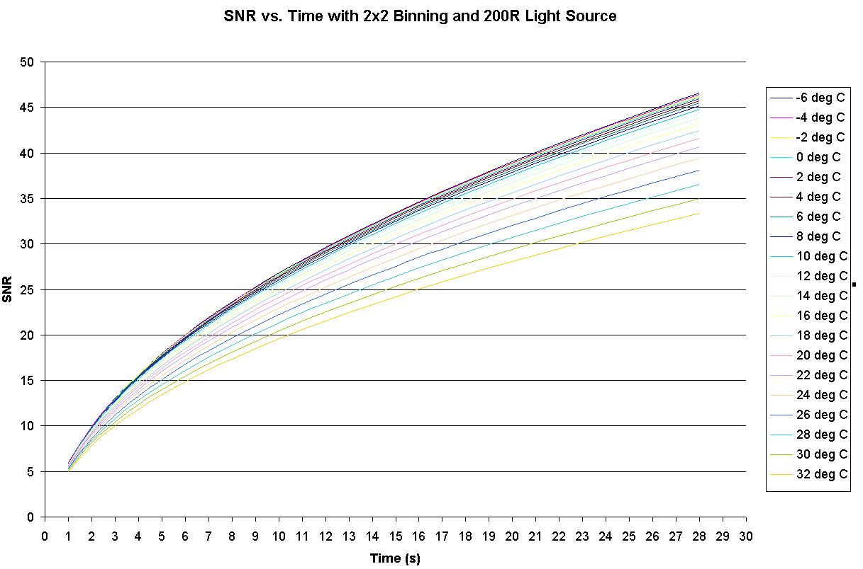
Figure 4.60 Imager SNR vs. time with 2 x 2 binning and 200-R light source

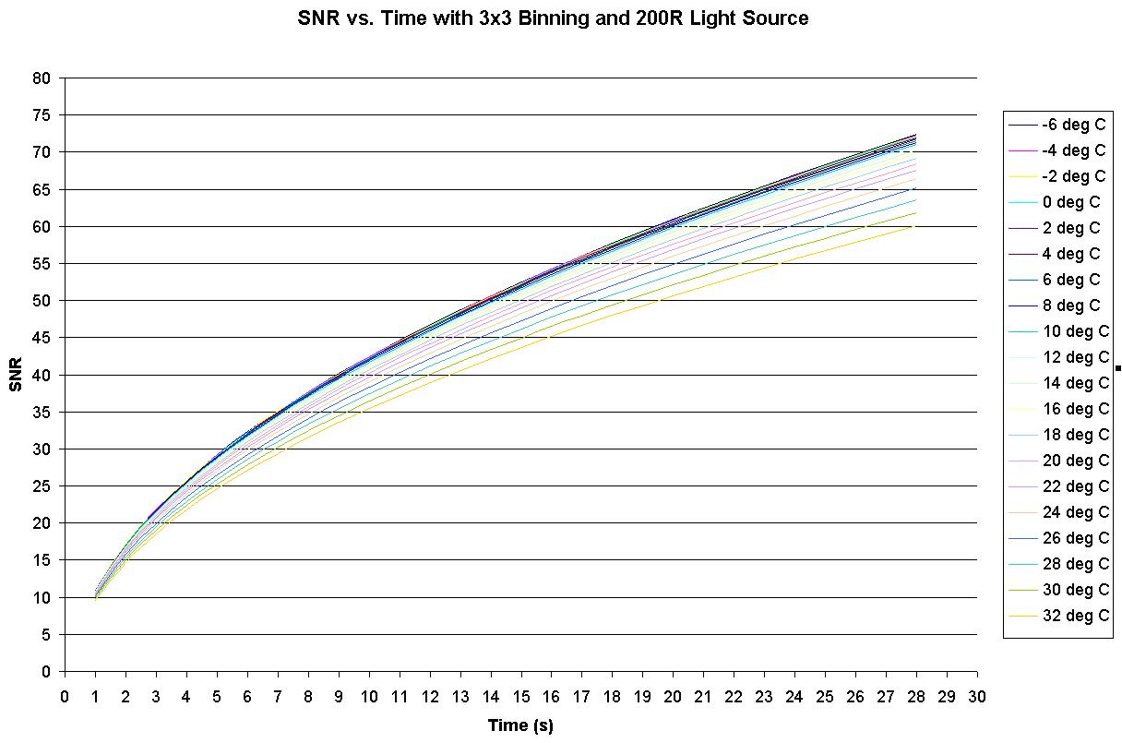
Figure 4.61 Imager SNR vs. time with 3 x 3 binning and 200 R light source
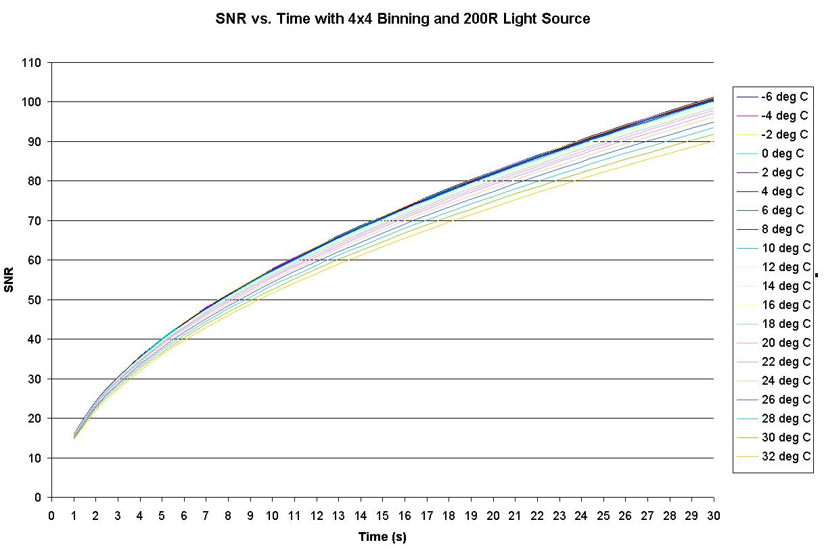
Figure 4.62 Imager SNR vs. time with 4 x 4 binning and 200-R light source
    - IBP

The SNR for the three photometers (IBP, HP, and HBP) was determined in a different manner as the camera. Because the photometers did not have a cooler of any sort attached to the photomultiplier tubes, and it was not convenient to operate them in an oven or refrigerator; I was only able to operate them at room temperature (about 22 °C). However, even when operating at room temperature, they experienced very little dark current, quite a bit lower than that given in the specifications of Figure 3.9 (page 19). Therefore, the SNR values were only calculated at room temperature; if it works at room temperature, it will also work at lower temperatures. Table C.2 in Appendix C summarizes the signal and noise properties of the IBP.

The total signal was calculated using the count sensitivity plots of Figure 3.15 (page 21) operating under a 200-Rayleigh light source. I simplified the calculations in the same manner as the Imager by treating the filter as having an infinitesimally narrow bandwidth located at the peak transmissivity. The resulting SNR values of the IBP at different integration times and at room temperature is given in Table 4.12.
Table 4.12 IBP SNR values at room temperature
Integration Time  (s) | Dark Count  (e-) | Signal Count  (e-) | SNR
1 | 5 | 1946 | 44
2 | 10 | 3 893 | 62
3 | 15 | 5 839 | 76
4 | 20 | 7 786 | 88
5 | 25 | 9 732 | 98
6 | 30 | 11 679 | 107
7 | 35 | 13 625 | 116
8 | 40 | 15 572 | 124
9 | 45 | 17 518 | 132
10 | 50 | 19 465 | 139

The IBP needs to integrate for at least 5 s before reaching an SNR of 100. The exposure period could have been less if the filter was not built smaller than what we specified (Barr botched the order). The decrease in filter surface area permits less light to the photometer and causes the SNR to go down. However, all is not lost, because the photometer will operate synchronous to the camera, and in order for the camera to achieve an SNR of 50, it must expose for about 8 s, large enough to put the IBP SNR well above 100.
    - HP and HBP

The SNR calculations for the HP and HBP were calculated in a similar manner as those for the IBP with one exception: because the HP and HBP have a bandwidth that is ten times wider than the IBP filter bandwidth, the total light striking their photomultiplier tubes was calculated assuming a finite bandwidth equal to the FWHM of their filters, instead of an infinitesimally narrow bandwith as was the case with the IBP. The total light striking the HP and HBP photomultiplier tubes was calculated by multiplying the FWHM of each filter given an average transmissivity (about 0.5) by the minimum light intensity per meter expected (200 Rayleighs/m). This simplification treats the filter quantum efficiency as having a bandwidth equal to the FWHM, centered at the peak transmissivity, and equal to the average transmissivity across the entire bandwidth. All calculations were made with respect to the HP and should be accurate for the HBP.

Table C.3 in Appendix C summarizes the signal and noise properties of the HP and HBP. The resulting SNR values of the HP and HBP at different integration times and at room temperature are given in Table 4.13. The HP and HBP easily reach an SNR above 100 after 1 s. This is due in large part to their large 3-in lenses, low dark current, and because the photomultiplier tubes at their wavelengths of interest have a sensitivity that is three times greater than the sensitivity at the IBP wavelengths of interest.
Table 4.13 HP and HBP SNR values at room temperature
Integration Time  (s) | Dark Count  (e-) | Signal Count  (e-) | SNR
1 | 5 | 29 554 | 171
2 | 10 | 59 108 | 243
3 | 15 | 88 662 | 297
4 | 20 | 118 217 | 343
5 | 25 | 147 771 | 384
6 | 30 | 177 325 | 421
7 | 35 | 206 880 | 454
8 | 40 | 236 434 | 486
9 | 45 | 265 988 | 515
10 | 50 | 295 542 | 543

  - Communication

There exist three separate RS-232 lines in the instrument. Figure 4.63 shows how they are routed. All three RS-232 lines are three-wire, with a TX, RX, and ground pin. The default baud rate is 115 kbaud, or 14.4 kbyte/s. The speed is set during the initialization process of each computer and persists until the next reboot.

There are two basic types of communication: command and file. Command communication is the transmission of a single string of text by a sender to a receiver. File communication is more complex. A sender opens a file from memory, breaks it into manageable chucks, and transmits each chunk across a serial line to the receiver. The receiver intercepts each chunk, reconstructs the file, and saves it to memory. In essence, file communication can be treated as a series of command communications with additional overhead.
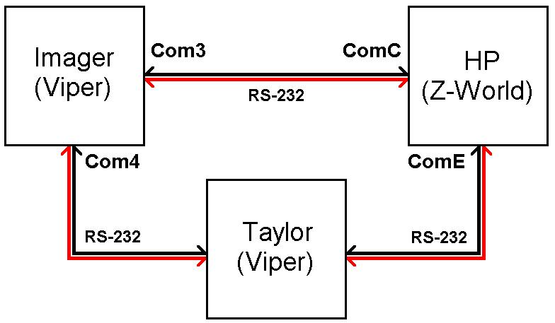
Figure 4.63 Instrument serial connections

Table 4.14 lists the type of communication that can occur on the various serial lines.
Table 4.14 Instrument communication types
Sender | Receiver | Communication | Type
Imager | Taylor | Keogram exposures | File, Command
Imager | Taylor | Full-Frame exposures | File, Command
Imager | Taylor | Operational log | File, Command
Imager | HP | Request for IBP background counts | Command
Imager | HP | IBP active/inactive designation | Command
HP | Taylor | HP and HBP counts | File, Command
HP | Taylor | Operational log | File, Command
HP | Imager | IBP background counts | Command
Taylor | Imager | Orbital times file | File, Command
Taylor | Imager | Control file | File, Command
Taylor | Imager | Command file | File, Command
Taylor | Imager | Real-time clock synchronization | Command
Taylor | HP | Orbital times file | File, Command
Taylor | HP | Control file | File, Command
Taylor | HP | Real-time clock synchronization | Command

    - Command communication

Command communication is the bedrock in which all communication, even file communication, rests upon. This form of communication is used for nonfile transfers, such as clock synchronization, that only require transmission of low-level strings. There exists three functions to implement command communication: check_for_command(), read_raw(), and write_raw().
      - write_raw()

The write_raw() function writes a string to a specified port. Each string will have the text "eos\0" tagged on the end to let the receiver know when it has read in the entire string.
      - check_for_command()

The check_for_command() function performs a quick read on a specified port. It is used when communication is not expected. It only looks for communication for a few milliseconds and exits if none is present. This function is used primarily for detecting commands requesting an action, such as the Taylor computer requesting to synchronize the Imager computer's real-time clock, etc. Any commands intercepted by this function have their terminating "eos\0" string stripped off and the remaining string is passed by reference to the calling function.
      - read_raw()

The read_raw() function is used most of the time when reading data off a specified port. It is used when the receiver knows that communication is expected. This function operates in almost exactly the same fashion as check_for_command(), except that it will wait much longer before timing out. Any strings intercepted by this function have their terminating "eos\0" string stripped off and the remaining string is passed by reference to the calling function.
    - File communication

File communication is handled by two functions: download_file() and upload_file(). These functions are based on lower level functions read_raw() and write_raw(). The function upload_file() is called by the computer when it wants to transfer a file from it, the host, to another computer, the receiver. Upon first hearing word from the host computer that it is to receive a file, the receiver computer will call download_file() to manage the flow of data coming from the host computer.

Three parameters are passed to upload_file(): port, source, and destination. The variable port specifies the rs-232 line to communicate the file across, source specifies the full path location on the source computer of the file, and destination specifies the full path location on the destination computer where the function wants to save the file.

The transmission process is coordinated by upload_file(). It performs some limited error checking by comparing the number of bytes it sent to the number of bytes received by download_file() for each packet sent. If there is a discrepancy, it issues a cancel command to download_file() and resends the data. Any error encountered by upload_file() in the communication process is logged in a file that can be read at a later date.
  - Software

See Appendix E Design Documents CD (page 102) for the complete Viper and LP3500 source code.
    - Imager

The Imager follows the general operational cycle illustrated in Figure 4.64

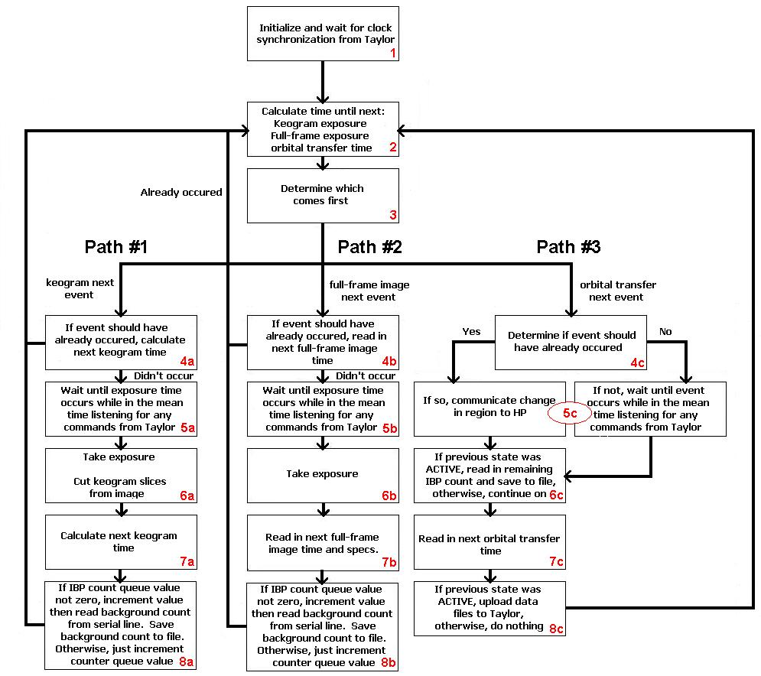
Figure 4.64 Imager operational cycle
      - Operational flowchart explanation

The steps labeled in Figure 4.64 are explained in more detail as follows.

1. The first step in the operational cycle, one that occurs at boot-up, is the initialization of the Viper processor. Initialization prepares the Viper for operation and needs to occur before anything else takes place. The major events that occur during the initialization process are listed in the following.
- Initialize global system variables.
- Wait for time synchronization from Taylor.

The last step is very important. Before the Imager is allowed to proceed into full operational mode, it needs to synchronize its real-time clock to that of Taylor. This is because the Imager uses time files to outline the regions of operation of the instrument in space and needs to have an accurate reckoning of the current time in order to properly use them. In addition, it must know the exact time when any measurement is taken so that scientists on the ground can accurately determine where along the orbital path the measurement was taken.

2-3. After clock synchronization the Imager will load into memory any existing control files, such as orbital times, control, and full-frame image times. Assuming it has each of these files, it will determine which event will occur first: keogram (path #1), full-frame image (path #2), or orbital transfer (path #3). It does this by subtracting the time since the epoch of each event from the current time, whichever results in the smallest difference is serviced first. The first keogram time is not explicitly given. It is calculated by adding the initial delay specified in control_file.text to the beginning of the active region.

Path #1: Keogram

4(a). If the Imager ascertains that a keogram exposure is to take place next, it will determine if the event time has already passed (e.g., the Imager was distracted and did not detect the event in time). If so, the Imager will jump back to step 2; otherwise it will continue to step 5(a).

5(a). The Imager waits for the exposure time to elapse. It will listen for any commands coming from the Taylor computer during this period. I originally wanted to implement the waiting period through interrupts and have the program count the number interrupts until the exposure time. However, I was not able to figure this out in time so I implemented it in a less efficient method by periodically comparing the time until exposure with the current time. When the time has elapsed, it will issue the command to the camera to take the picture.

The signal that drives the shutter of the camera is used to control the counter chips on the photon counter board associated with the IBP. The signal activates the counters only when the shutter of the camera is open. Upon completing the exposure, the Imager will send a command to the photon counter board to send over the count value associated with the latest exposure.

6(a). The image coming off the camera is a full-frame image. The Imager calls the function reduce_image() to strip out the sub-image slices as specified in control_file.text. The original image is then deleted.

7(a). The next keogram time is computed by taking the previous exposure time and adding to it the period between exposures specified in control_file.text.

8(a). The variable counter_queue keeps track of the number of background count values that are outstanding. If counter_queue is equal to zero, indicating there is no prior outstanding request other than the most recent one for any background counts, the Imager will jump back to step 2; otherwise, it will read in the count value off the line (after it had been transmitted by the photon counter board across the serial line to the Viper) and save it to memory.

The reason for not attempting to read it from the serial line immediately after the exposure is because the photon counter board will not have enough time to provide it given the inherent delay between when the request is transmitted, its being received, and the count value read off the counter ICS, and when it is transmitted to the Viper. The only way to guarantee the availability of it after the exposure is to add a delay. A delay is undesirable because it would reduce the frequency of exposures. It can be avoided by requesting the counts after a one exposure delay.

Whether a count value is read in or not, count_queue is incremented by one. count_queue is a global variable that keeps track of the number of outstanding count requests.

The Imager then jumps back to step 2 and start the process over again.

Path #2: Full-frame exposure

The process for taking a full-frame exposure is identical to that of a keogram exposure with a few notable exceptions. First, reduce_image() is not called because the Imager is now interested in the entire image and not just slices of a full-frame image. Second, the full-frame image time is read in from ff_image.text and not calculated from control_file.text.

Path #3: Orbital transition

4(c). If the Imager ascertains that a transfer of orbital region is to take place next, it will determine if the event time has already passed (e.g., the Imager was distracted and did not detect the event in time). If so, it will immediately change state.

5(c). If the transfer time has NOT already passed, it will wait for the transition time to occur, at the same time listening for any commands from the Taylor computer. I originally wanted to implement the waiting period through interrupts and have the program count the number of interrupts until the transition time. However, as stated previously, I was not able to figure this out in time, so I implemented it in a less efficient method by periodically comparing the transition time to the current time.

6(c). If the Imager is coming out of the active region, it will tell the photon counter board to turn OFF the camera power and send over the last remaining IBP count to the Viper. If the Imager is coming out of the inactive region, it will tell the photon counter board to turn ON the camera power.

7(c). The Imager reads in the next orbital transfer time.

8(c). If the Imager is coming out of the active region, it will upload the data files and operation log to the Taylor computer. Otherwise, it will do nothing.

The Imager then jumps back to step 2 and starts the process over again.
    - HP and HBP

The HP and HBP follow the general operational cycle illustrated in Figure 4.65.
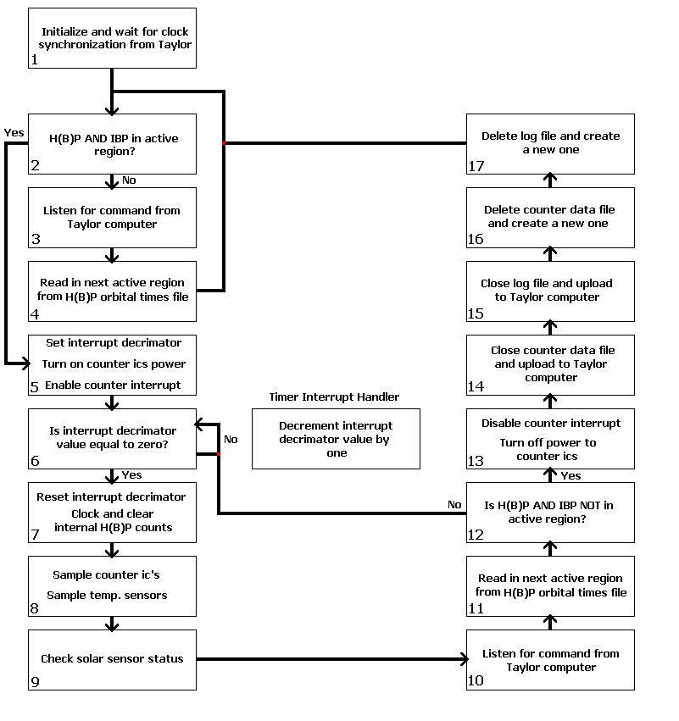
Figure 4.65 HP and HBP operational cycle
      - Operational flowchart explanation

The steps labeled in Figure 4.65 are explained in more detail in the section below.

1. The first step in the operational cycle, one that occurs at boot-up, is the initialization of the LP3500. Initialization prepares the H(B)P for operation and needs to occur before anything else takes place. The major events that occur during the initialization process are listed below.

- Initialize global system variables.
- Setup and initialize file system.
- Setup and initialize PWM interrupt on pin 1.
- Setup PWM signal channel 0 to drive counter timer interrupt.
- Turn off power to counter ICS.
- Wait for time synchronization from Taylor.

The last step is very important. Before the H(B)P are allowed to proceed into full operational mode, it needs to synchronize its real-time clock to that of Taylor. This is because the H(B)P uses time files to outline the regions of operation of the instrument in space and needs to have an accurate reckoning of the current time in order to properly use them. In addition, it must know the exact time when any measurement is taken so that scientists on the ground can accurately determine where along the orbital path the measurement was taken.

2-4. Upon initialization, there are two possible paths for the H(B)P to take at this point. If either the H(B)P or the IBP are in the active region, the H(B)P will go into counting mode, and continue on to step 5.
If both instruments are not in the active region, the H(B)P will stay within a while loop and wait for either system to move into the active region. It will detect any change of state on the part of the IBP by periodically checking the serial line through listen_for_command() for the command indicating a transfer into the active region. It will detect any change on the part of the H(B)P by periodically calling read_hp_orbital_times(). The function read_hp_orbital_times() opens an orbital times file stored in memory and searches sequentially through the file until it finds the time associated with the next orbital transfer, assuming all the orbital transition times have not already occurred and the file exists in memory in the first place. It will infer the region the H(B)P will move into by noting the line number it finds the transition time on; odd lines refer to transitions into the active region, even lines refer to transitions into the inactive region. By noting the next transition time, and transition region, the H(B)P can know the current orbital region; i.e., if the next transition time will be into the inactive region, the H(B)P must currently be in the active region. If the orbital times file does not exist, or is outdated, the function will stamp the region of operation as unknown and wait until a new orbital times file is uploaded.

5. The H(B)P is almost ready to operate the photometers. Before it does so, it turns on the power to the counter ICS, activates the timer interrupt on pin 1 of the digital inputs that will be used to record each rising edge of the PWM signal, and initializes a variable, called the interrupt decremator, to the number of interrupts that will occur during one integration period of the photometers. The default PWM frequency is 3600 Hz and the default integration period of the photometers is 1 s, so the interrupt decremator is set to 3600. Each time an interrupt is called by the PWM signal, the interrupt decremator is decimated by 1, until it eventually reaches zero, at which point the counters are sampled.

6. The H(B)P is now in full counting mode. It will sit in a while loop until the 1-s photometer integration period has elapsed.

7. When the 1-s integration period has elapsed, the H(B)P will immediately reset the interrupt decremator back to 3600, clock any H(B)P counts onto the output registers of the counter ICS, then clear their internal count values. This will re-initialize the H(B)P counters for the next integration cycle. These operations must occur as quickly as possible after the termination of the integration period because the next integration period begins immediately afterward.

8. The H(B)P next calls sample_counters(). This function processes all of the count values that come off the counter ICS for both the H(B)P and the IBP. It first checks to see if the Imager is in the active region. If so, it will call listen_for_command() to see if the Imager has issued a request across the serial line for a count from the IBP counters. If there is a request, it will read in the count value from the IBP counters and relay it to the Imager, otherwise, it will skip this step.
Next, the H(B)P will determine if the H(B)P is in the active region. If so, it will read in the count values from the H(B)P counter ICS. These values will be stored in a data file on the LP3500 and will ultimately be uploaded to the Taylor computer when the H(B)P enters the inactive region.
After the H(B)P has read in either the H(B)P counts, the IBP counts, or both, it then takes a reading of the temperature from each of the eight A/D inputs by calling sample_temp_sensors(). Each temperature measurement is averaged over ten successive samples in order to minimize any error. Temperature measurements are taken whenever any of the instruments are in count mode in order to provide a more complete picture of the environment the instruments are operating under.
- The H(B)P will next call the function check_sensor_status(). The function check_sensor_status() allows the H(B)P to manage the power states of the photometer systems according to the state of the photodiodes associated with each photometer system and the current position of the power states of each photometer system in an overall power state cycle.

As mentioned in the hardware section, both the H(B)P and the IBP utilize photodiode activated power circuitry to detect if excessive light strikes either system, and to shut down the power to each accordingly. This can happen at any time during the active region. The shutdown mechanism is designed to work in tandem with the operation of the LP3500, and it provides the H(B)P the ability to sense the power state of each system and to act upon it as it sees fit.

The power cycle for both the H(B)P system and the IBP system is illustrated in the Figure 4.8.

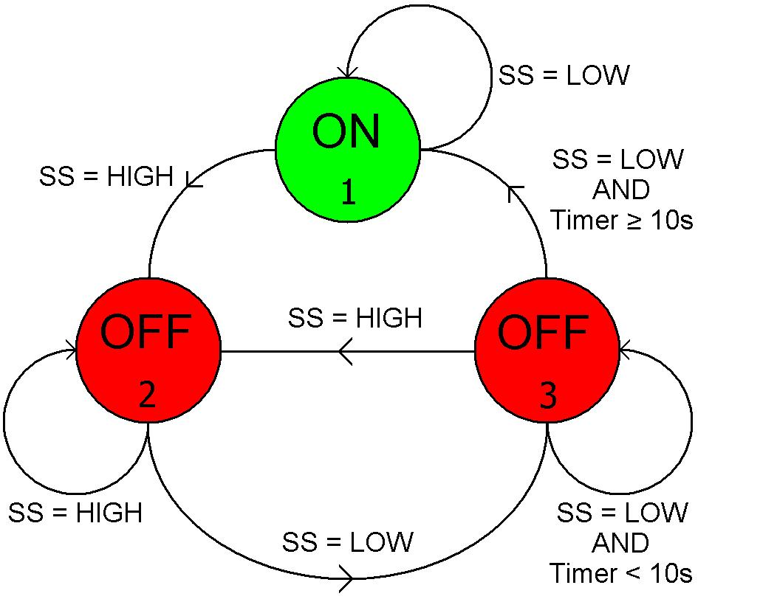
Figure 4.66 Photometer shutdown circuit state diagram (SS → Solar Sensor associated with photometer)

State 1: The power state of the photometer is initially ON. It will stay in this state so long as the photodiode associated with the photometer system is not activated. Activation occurs whenever excessive light strikes the photodiode sufficient to exceed a predetermined voltage threshold. When this occurs, power to the photometer is shut off and the photometer moves to State 2.

State 2: The photometer will remain in this state until light levels have abated and the photodiode de-activates. When this occurs, the photometer power still remains off, but the power state moves to State 3.

State 3: The photometer will remain in this state for a predetermined period of time (by default 10 s) from the last occurrence of the photodiode being activated. This is done to ride out any potential "bounce" in the signal coming off the solar sensor. If the photodiode were to become activated during this delay period, the power state immediately reverts back to state 2 until the photodiode again deactivates and the power state moves back to state 3 to begin the ten second delay over again. This situation is depicted in Figure 4.67. Delay Period I corresponds to the intrinsic electromechanical delay that exists between the time the photodiode sensor is tripped to when the relay is activated, approximately 1 ms. Delay Period II corresponds to the sum of Delay Period I and whatever additional delay the user may want to add to ensure the photometer reactivates when no excessive light is present. The default time for Delay Period II is 10 s.
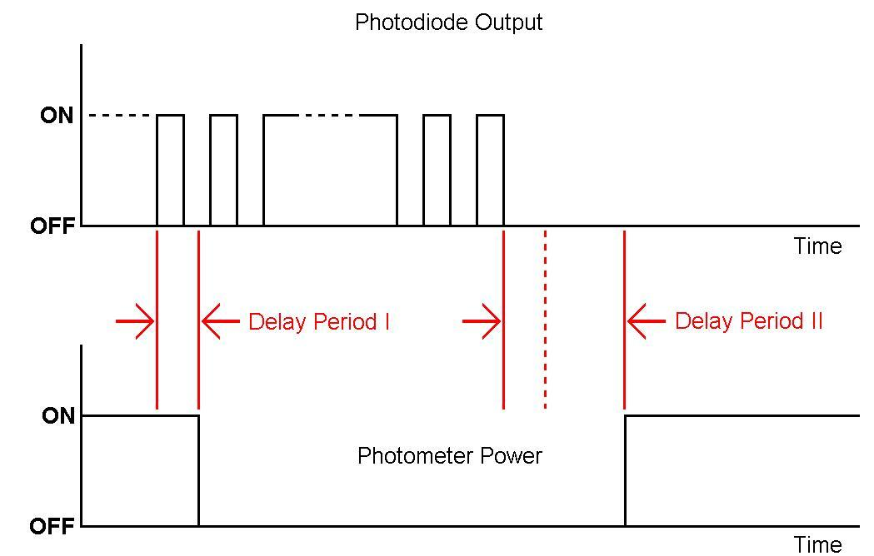
Figure 4.67 Sample operation of the photometer shutdown circuit

9. (continued) Upon completing the 10 s delay, the photometer moves back to State 1 and power is again supplied to the photometer.
  - After checking the status of the photodiodes, the H(B)P now listens for any communication from either the Taylor or Imager computer. Next, it determines if the H(B)P moved into the inactive region by calling read_hp_orbital_times().

There are two possible paths for the H(B)P to take at this point. If either the H(B)P or the IBP are in the active region, the H(B)P will go back to step 6 and
wait for the next photometer integration cycle to complete; otherwise, the H(B)P will proceed to step 13.

13-17. The H(B)P has completed its active cycle and immediately de-activates the timer interrupt on pin 1. It then shuts off power to the photometers and the counter ICS. This saves a tremendous amount of power and should be done whenever they are not in use.

The last step in the operational cycle is to communicate the data and log files generated during the previous active region, and located on the LP3500, to the Taylor computer. Memory on the Z-World is limited, so after each file is uploaded they are deleted from memory, to make way for new ones for the next active region. Upon successfully uploading both files, the H(B)P enters step 2 and starts the entire operational cycle over again.
- Conclusion

This project proved to be a daunting task because of its complexity. I underestimated the size and scope of the project and what was required of it. In addition, my attention was often split between the project and my courseload. As a consequence, although the majority of the project was completed, and most of the instruments are functional, there are a few items that I never had enough time to resolve.
  - What Has Been Accomplished

The mechanical structure, with all of the instrument components placed inside, was put through a fit check and vibration test at Taylor and passed.

The Taylor interface connector was thoroughly tested. Power was supplied through the connector to each of the instruments seperately and together. The Ethernet and rs-232 connections were tested by transmitting files back and forth across each line.

Each detector was indivually tested before being placed inside the instrument box. The camera was tested by taking several sample images at different exposure periods, temperatures, and pixel binning, and analyzing the resulting images. The tests showed that the camera works fine under a wide range of scenarios.

The photometers were tested by operting them at different light levels and observing both the shape of the pulses, and the number of pulses, coming off the photometers. The pulses showed a consistent width and height and the number of pulses was shown to depend directly on the incident light striking the photomultiplier tube of the photometer.

The instruments were all wired according to the electrical tables found in Appendix A. Basic continuity tests were performed between connected components and they verified that the connections were all properly made.

The photodiode operated shutdown board was tested by exposing the photodiodes to different light intensities ranging from pitch dark to full brightness. The sun sensors turned off the relays that supplied power to the photometers whenever the incident light was above a threshold set by potentiometers on the board. The sensitivity of the shutdown board was adjusted to different levels and this caused the point in which the photometer power was shut off to change accordingly.

Most of the instrument code was tested thoroughly. The Imager was able to successfully perform clock synchronization, download and parse control files from the Taylor computer, operate the camera in either keogram or full-frame mode based on the information stored in the control files, and download the images to the Taylor computer at the end of each active region. The code operating the HP and HBP was also tested thoroughly. The HP was able to successfully perform clock synchronization, download and parse all control files except control.text, count the pulses coming off the IBP, HP, and HBP and read in the temperature data from the thermistors, store the data to memory, and upload the data to the Taylor computer at the end of each active region.

Emperical SNR data was gathered from the Imager and the three photometer imaging systems. The SNR values of the camera were determined across different temperatures, exposure times, and pixel binning; the SNR values of the photometers were determined at room temperature only.
  - What Still Needs to be Done

Signal ground is showing up in the instrument box. This is coming from two sources: screws securing all three photometer cases to internal walls and from the optical assembly threaded into the front flange of the camera. This will not be allowed in the final instrument and needs to be corrected. The best way to fix this is to substitute the offending aluminum parts with plastic (Delrin) parts.

The latching mechanism of the shutdown board does not work properly. Looking at Figure 3.32 (page 36), if IBP_DIODE_OVERRIDE or H(B)P_DIODE_OVERRIDE is HIGH, the OR gate to the left always stays HIGH, regardless the state of the photodiodes, keeping the photometers turned OFF. It should stay at whatever state the photodiode is currently operating under. This needs to be corrected by replacing the OR gate with a latch.

Some of the photometer cables are not adequately shielded. This causes the counts to appear either really large or not at all on the photon counter board.

The 5-V relay on the photometer interface board does not work; it always stays on.

There are a number of issues pertaining to the code executing on both the Viper and LP3500. These include:
- The communication code for the HP was not working properly when the instrument was handed over to Taylor before the vibration tests; it had been working fine up to that point in time. The LP3500 receives characters fine from the Taylor computer up until it fills its communication buffer, then it would stumble on any additional characters.
- The LP3500 is having trouble handling control files. It appears to receive them fine across the serial line (because they are small), but it is unable to reopen them and properly initialize its global variables from them.
- The code on the LP3500 that checks the power states of the photometers was never tested because of the problem with the latches on the shutdown board.
- The code handling the counts from the IBP on the Viper and the LP3500 has not been fully tested.
- All code needs to be thoroughly debugged to work out any hidden problems that were never identified. This is a process that should occur on a regular basis until the time the instrument is handed over to Taylor for the last time, sometime in late January.

The sensitivity of the shutdown board comparators is not set at the proper levels. It needs to be adjusted so that the photometers are powered down when the light level exceeds that found at dawn.

No cold fingers were installed in the instrument. There needs to be one for the CCD array in the camera and the photomultiplier tubes in all of the photometers. The cold fingers must not touch any of the surrounding aluminum structure and must couple to a single cold finger that interfaces to Taylor. The cold fingers are to be made from coaxial cable and connect to the Taylor cold finger by an SMA connector.

There are currently five thermistors present in the instrument. Eight are allowed by the LP3500. There are thermistors for all three photomultiplier tubes, the Imager, and IBP filter. At least one of the remaining three thermistors needs to be applied to the CCD array housing of the Imager camera.

The optical filters for the HP and HBP never arrived. There currently exists a gap where they belong in these two instruments. When they do arrive, their transmissivity, along with the transmissivity of the two that we already have (the IBP and camera filters), should be emperically verified (even though Barr Associates supplied the transmission profiles of the Imager and IBP filters).

